Report on the CENSUS OF SOCIO-ECONOMIC FACILITIES IN POLITICAL WARDS of NIGER STATE
2022
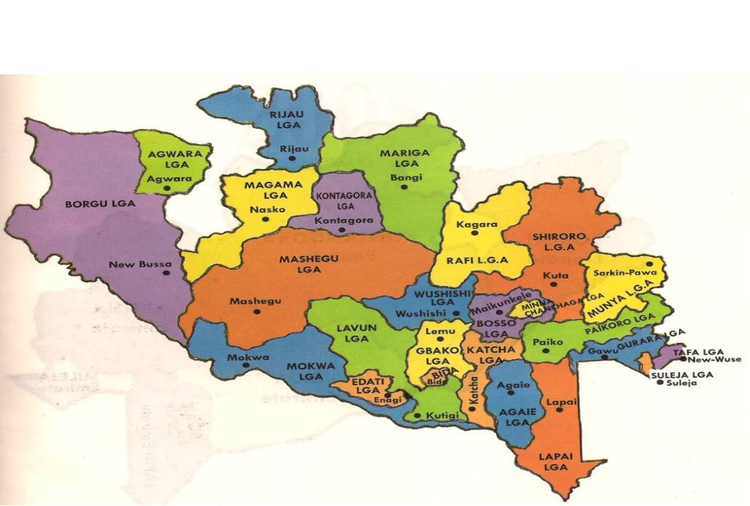

Niger State Bureau
of Statistics (NSBS)

NIGER STATE BUREAU OF STATISTICS (NSBS)

Vision
To supply Statistical information for proper planning, good decision-making, sound economic management, proper development and good Governance towards the attainment of the Present Administration’s Developmental Policy of Urban Renewal and Rural Development.

Mission
To collect and provide comprehensive, timely, relevant and reliable data for the socio-economic Development of Niger State.

NIGER STATE BUREAU OF STATISTICS
Niger State Bureau of Statistics (NSBS) was established through the enactment of “Niger State Statistics law” in 2011 as an autonomous body from the former Niger State Department of Budget and planning by the Administration of Dr. Mua’zu Babangida Aliyu, the Former Chief Servant and Former Executive Governor of Niger State. The major purpose of establishing the NSBS by the State Government is to enhance planning process in the State by repositioning Statistics to provide a basis for evidence-based planning towards the attainment of the State’s Government’s aspirations.
The Bureau was established through the enactment of the “Niger State Statistics Law” of March 2011 with the following responsibilities:
- Development and management of the State’s official statistics. It is the authoritative source and custodian of official statistics in the State;
- Co-ordination of the State Statistical System;
- Advise the State and Local Governments on all matters related to statistical developments;
- Developing and promoting use of statistical standards and appropriate methodologies in the State Statistical System;
- Collect, compile, analyse, interpret, publish and disseminate statistical information alone or in collaboration with other agencies either governmental or non-governmental;
- Development and maintenance of a comprehensive socio-economic State Data Bank; and
- Performing all other functions relating to statistics, which the State Government may from time to time direct.

FOREWORD
This is another edition of the report on the “Census of Socio-Economic Facilities in Political Wards of Niger State” which was conducted in November, 2022 in all the 274 Wards of the 25 Local Government Areas (LGAs) of the State. It is an update of that which took place in August 2013 and also part of the effort of the Niger State Bureau of Statistics to make available relevant data that will be useful for policy formulation, planning and decision making process.
The Census exercise was aimed at making available to the general public some basic data regarding the spread of socio-economic facilities in all the 274 Wards of the State. All the data contained in the publication were obtained from each of the Wards through their respective Councilors in collaboration with Directors of Planning, Research and Statistics (PRS) of respective Local Government Areas in the State. It is our fervent hope and desire that the data contained in this report will be useful for the purpose of policy formulation, decision making and planning in the State.
We welcome constructive criticisms and suggestions that will facilitate the enhancement of subsequent exercise(s) of this nature.

Abdulganiyu Bello,

Statistician General, Niger State Bureau of Statistics

ACKNOWLEDGEMENT
We acknowledge and appreciate the leadership qualities and determination of the Governor of Niger State, Alhaji Abubakar Sani Bello towards transformation of Niger State. We are indeed indebted to him for ensuring the provision of conducive working environment for Statistical activities to thrive in the State.
The roles played by the twenty Five (25) Local Government Areas’ Directors of Planning, Research and Statistics (DPRS) particularly their suggestions during the Zonal level preparatory training for the exercise, is highly commendable. Not forgetting the ward Councilors who served as respondents and our Area officers and Members of staff of the Local Govt. Areas’ Department of Planning Research and Statistics who administered and also ensures the retrieval of the questionnaire.
The Bureau commends the co-operation of Ministry of Education, Ministry of Health, other line Ministries and of course Local Government Areas that responded to our request for the validation of the data that concerns them.
Finally, we commend the efforts of members of staff of the Bureau and all those that directly or indirectly contributed to the success of this exercise. We are hopeful that we can always count on them in our future endeavors.

Naibi Adamu,

Director Statistics, Niger State Bureau of Statistics

TABLE OF CONTENT
Cover Page…………………………………………………………………………….i
Vision and Mission Statements………………………………………………….iii
Brief about Niger State Bureau of Statistics………………………………..iv
Foreword……………..………………………………………………………………..v
Acknowledgement……………………………………………..……………………vi
Table of Content..……………………………………………………………………vii
Executive Summary………………………………………………………………….ix
Background to the Census………………………………………………………..xi
Chapter One
Education – Nursery/Primary Schools in Niger State, 2022…………….1
Tables 1.1 – 1.26 (Number of Nursery/Primary Schools)…………….….2
Chapter Two
Education – Secondary Schools in Niger State, 2022…………………….19
Tables 2.1 – 2.26 (Number of Secondary Schools)………………………..20
Chapter Three
Health Establishments in Niger State, 2013………………………………….35
Tables 3.1 – 3.2 (Public Health Establishments)……..…………………….36
Tables 3.3 – 3.4 (Private Health Establishments)………………………….38
Chapter Four
Sources of Drinking Water in Niger State, 2013…………………………….40
Table 4.1 (Main Source)……………………………………………………………..41
Table 4.2 (Alternative Source)…………………………………………………….42
Table 4.3 – 4.28 (Functional and Non-functional Boreholes…………….43
Chapter Five
Sources of Agricultural Inputs in Niger State, 2022……………………….57
Table 5.1 (Fertilizer)……………………………………………………………………57
Table 5.2 (Seedlings)………………………………………………………………….58
Table 5.3 (Insecticides)………………………………………………………………59
Table 5.4 (Pesticides)…………………………………………………………………60
Table 5.5 (Herbicides)………………………………………………………………..61
Chapter Six
Major Markets and Slaughter Slaps in Niger State, 2022…………………62
Table 6 (Distribution of Major Markets and slaughter slaps)…………..62

Chapter Seven
Major Motor Parks in Niger State, 2022……………………….……………….63
Table 7 (Distribution of Major Motor Parks)……………………………………63
Chapter Eight
Banks in Niger State, 2022……………………….………………………………….64
Table 8 (Number of Banks)………………………………………………………….64
Chapter Nine
Hotels/Guest Houses in Niger State, 2022……………………….……………65
Table 9 (Number of Hotels/Guest Houses)…………………………………….65
Chapter Ten
Access to Electricity in Niger State, 2022……………………….……………….66
Table 11 (Number of Ward with access to Electricity)...…………………..66

LIST OF FIGURES
Figure 1 - Nursery/Primary Schools in Niger State……………………….…3
Figure 2 - Secondary Schools in Niger State……………………………….….21
Figure 3 - Public Health Establishments in Niger State……………………37
Figure 4 - Private Health Establishments in Niger State…………………..39
Figure 5 - Access to Electricity in Niger State………………………………...67

EXECUTIVE SUMMARY

One of the primary responsibilities of Government is the promotion of the general welfare of the citizens. The provision of social and economic facilities to the society is one of the major means through which Government strive to accomplish this primary obligation. There is the need however, to have the inventory and basic facts about existing socio-economic facilities in the society to guide the Government in the process of policy formulation, decision making and planning in terms of provision and equitable distribution of these facilities. Hence, the “Census of Socio-Economic Facilities in the Political Wards of Niger State” was conceived by the State’s Bureau of Statistics as a means of providing some of the basic data that would be useful for policy formulation, decision making and planning in the State.
Some of the basic facts as reported during the conduct of the Census exercise were that:
- 4,579 public and private Nursery/Primary Schools made up of 3,137 (68.50%) public Nursery/Primary Schools and 1,442 (31.50%) private Nursery/Primary Schools exist in the State;
- 975 public and private Secondary Schools consisting of 557 (57.13%) public Secondary Schools and 418 (42.87%) private Secondary Schools exist in the State;
- 4,516 Health Establishments made up of 2,912 (64.48%) and 1,604 (35.52%) Public and Private Health Establishments exist in the State respectively;
- Borehole is the main source of drinking water in 177 (52.06%) wards while only 42 (12.35%) of the Wards has access to Pipe-Borne Water.
- 97 Wards obtain fertilizer from Government sources, 163 from Open market and 114 from both sources (Government/Open market);
- 38 wards acquire seedlings from the Government, 251 from Open Market and 50 from Government/Open market;
- 16 wards get insecticides from the Government, 265 from Open Market and 25 from Government/Open market;
- 13 wards buy pesticides from the Government, 253 through open market and 27 from both sources (Government/Open Market);
- 8 wards obtain Herbicides from the Government, 263 from Open Market and 21 from Government/Open Market;
- 406 major markets and 288 Slaughter Slabs were recorded in the State;
- 216 major motor parks were captured during the Census;
- 110 Banking outfits exist in the State;
- There are 288 Hotels/Guest Houses in the State;
- A total of 192 out of the 274 Wards are connected with electricity.

BACKGROUND TO THE CENSUS
The need to ensure the availability of basic data on some essential facilities across the State necessitated the conduct of this Census. The essence was to provide data that shows the spread of these facilities across the 274 political wards to serve as a guide for equitable provision/distribution of social and economic facilities in the State. The Census was first conducted in August 2013, with a review of it the year 2022 and in all the 274 wards of the 25 Local Government Areas (LGAs) of the State.
Objectives
The objectives of the Census were to:
- Identify the distribution of socio-economic facilities (Primary and Secondary Schools, Health Establishments, Sources of Drinking Water, Major Markets, Banks etc) in all the political wards of the State;
- Provide baseline data that could serve as veritable tool for rural development; and
- To also serve as an update to the previous exercise conducted in 2013.

Coverage
The Census covered all the 274 wards in the 25 LGAs of the State.

Scope
The Census was limited to gathering data relating to the existence of the following facilities in each ward of the State:
- Public and private Primary and Post-primary institutions;
- Public and private Health Establishments;
- Sources of drinking water;
- Functional and non-functional Boreholes;
- Agricultural inputs (fertilizer, insecticide, herbicide, pesticide, and improved seedlings);
- Major Markets and Slaughter Slabs;
- Major Motor Parks;
- Banks;
- Hotels and Guest Houses; and
- Electricity

Data Collection Methodology for the First Edition
During the conduct of the first Edition of this Census, the Bureau collaborated with the Executives of the Ward Development Projects Committees to collect the required data in each of the wards of the State using predesigned questionnaire. The purpose of collaborating with the Committees was to ensure and facilitate the direct participation of the legally recognized representatives of the wards in order to ensure the credibility of the Census outcome.
The Ward Development Projects Committees established via the “Local Government (Establishment of Ward Development Projects Committees) Law, 2012” are the legally recognized representatives of the wards. The functions of the Committee in each ward are to “disburse, undertake any development project in the ward after identification and necessary detail appraisal from the ward”. The Committee consists of seven members in each ward and a Coordinator per LGA.
Census questionnaires were lodged and retrieved by staff of the Bureau in collaboration with Ward Development Projects’ Coordinators. Staff of the Bureau administered questionnaires with members of the Ward Development Committees serving as respondents in each of the wards. A total of two hundred and seventy four (274) questionnaires were administered across the State i.e. one questionnaire per ward while the list of towns and villages that are connected to electricity across the State was obtained from Niger State Electricity Board.

Data Processing and Analysis
Microsoft Excel was used for data entry and processing, while data analysis was done using Statistical Package for the Social Sciences (SPSS).
It is however noteworthy that, before data analysis was carried out, the outcomes of the processed data were sent to relevant organisations (Ministry of Education, Ministry of Health, SUBEB, Directorate of Ward Development Projects, and the twenty-five LGAs of the State) for their comments and observations regarding data that relates to their respective mandates. The purpose was to involve organisations in the validation of data that concerns them in order to: ascertain that data collected from the field are in conformity with the organization’s records; and ensure the credibility of the Census outcome. However, only the Ministry of Education, Ministry of Health, Directorate of Ward Development Projects, and five LGAs (Agaie, Bida, Chanchaga, Mashegu and Rafi) responded while SUBEB and the remaining twenty LGAs did not submit their comments and observations. Hence, it was assumed that SUBEB and the LGAs that did not respond are in agreement with the data concerning them as provided by the Ward Development Committees.
Data Collection Methodology for the Second Edition
Based on the importance of basic data of this nature to socio-economic development of the State, there is the need to have an update and availability of such data; thus, necessitated the conduct of this second edition of the Census in the 274 political wards in the 25 LGAs of the State. The essence is to provide data that shows update to the spread of these facilities across the political wards and to serve as a guide for equitable provision/distribution of social and economic facilities in the State. This second edition of the Census was also conducted in all the wards of the 25 LGAs of the State between October and December 2022.
For this second edition, the questionnaires were lodged and retrieved by staff of the Bureau in collaboration with Directors of Planning, Research and Statistics (DPRS) and elected councilors of the wards in the LGAs who acted as respondent for the data collection. A print out of the outcome of the previous exercise conducted in 2013 for each ward was also given out to serve as a guide and also for comparison. A one-day training on the data collection instrument was conducted for DPRS and Councilors by Directors of the Bureau so as to facilitate the administration of questionnaires in each of the wards. A total of two hundred and seventy four (274) questionnaires were administered across the State i.e. one questionnaire per ward. The Bureau Staff at the LGAs retrieved the completed questionnaires and sent same back to the Headquarters for data processing and analysis.
Data Processing and Analysis
Microsoft Excel was used for data entry and processing while data analysis was done using Statistical Package for the Social Sciences (SPSS).
Data entry and editing as part of data processing was carried out at the Headquarters by the designated staff of the Bureau. The outcomes of the processed data were sent to relevant organizations for their comments and observations regarding data that relates to their respective mandates. The purpose was to involve organizations in the validation of data that concerns them in order to: ascertain that data collected from the field are in conformity with the organization’s records; and ensure the credibility of the Census outcome as done in the previous exercise.

CHAPTER ONE
EDUCATION - Nursery/Primary Schools in Niger State, 2022
A total of 4,579 public and private Nursery/Primary Schools were recorded during the Census. This figure is made up of 3,137 (68.50%) public Nursery/Primary Schools and 1,442 (31.50%) private Nursery/Primary Schools.
Regarding the spread of public Nursery/Primary Schools, Mokwa LGA has the highest number of 277 followed by Shiroro and Lavun LGAs with 272 and 233 respectively while the least number of schools was recorded in Tafa LGA with 56 schools. Similarly, the highest number of private Nursery/Primary Schools (204) was recorded in Bosso LGA followed by Suleja LGA with 181 while the least number (9) was recorded in Agwara LGA.
Detailed of information about Nursery/Primary Schools by LGA are contained in Table 1.1 while those by wards for each of the 25 LGA are provided in Table 1.2-1.26.

TABLE 1.1
NUMBER OF NURSERY/PRIMARY SCHOOLS IN NIGER STATE BY LGA,2022

LGA | PUBLIC SCHOOLS |  |  |  | PRIVATE SCHOOLS |  |  |  | GRAND TOTAL
LGA | NURSERY | PRIMARY | NURS/PRI. | TOTAL | NURSERY | PRIMARY | NURS/PRI. | TOTAL | GRAND TOTAL
AGAIE | 2 | 136 | 12 | 150 | 0 | 2 | 23 | 25 | 175
AGWARA | 0 | 58 | 2 | 60 | 2 | 0 | 7 | 9 | 69
BIDA | 0 | 47 | 13 | 60 | 0 | 4 | 85 | 89 | 149
BORGU | 0 | 124 | 12 | 136 | 2 | 3 | 41 | 46 | 182
BOSSO | 0 | 113 | 1 | 114 | 0 | 0 | 204 | 204 | 318
CHANCHAGA | 0 | 28 | 35 | 63 | 4 | 15 | 112 | 131 | 194
EDATI | 0 | 99 | 2 | 101 | 0 | 0 | 20 | 20 | 121
GBAKO | 0 | 175 | 4 | 179 | 0 | 9 | 4 | 13 | 192
GURARA | 1 | 62 | 31 | 94 | 1 | 26 | 0 | 27 | 121
KATCHA | 0 | 166 | 1 | 167 | 0 | 3 | 23 | 26 | 193
KONTAGORA | 0 | 86 | 0 | 86 | 1 | 45 | 57 | 103 | 189
LAPAI | 0 | 150 | 11 | 161 | 2 | 0 | 53 | 55 | 216
LAVUN | 0 | 185 | 48 | 233 | 3 | 0 | 42 | 45 | 278
MAGAMA | 0 | 98 | 0 | 98 | 2 | 4 | 28 | 34 | 132
MARIGA | 0 | 105 | 3 | 108 | 5 | 19 | 11 | 35 | 143
MASHEGU | 0 | 100 | 1 | 101 | 0 | 4 | 35 | 39 | 140
MOKWA | 0 | 257 | 20 | 277 | 3 | 1 | 44 | 48 | 325
MUNYA | 0 | 115 | 3 | 118 | 2 | 0 | 36 | 38 | 156
PAIKORO | 0 | 150 | 5 | 155 | 0 | 0 | 37 | 37 | 192
RAFI | 0 | 98 | 8 | 106 | 1 | 1 | 27 | 29 | 135
RIJAU | 0 | 81 | 2 | 83 | 3 | 1 | 11 | 15 | 98
SHIRORO | 0 | 268 | 4 | 272 | 0 | 12 | 55 | 67 | 339
SULEJA | 13 | 48 | 17 | 78 | 0 | 0 | 181 | 181 | 259
TAFA | 0 | 53 | 3 | 56 | 1 | 7 | 102 | 110 | 166
WUSHISHI | 0 | 63 | 18 | 81 | 0 | 3 | 13 | 16 | 97
TOTAL | 16 | 2,865 | 256 | 3,137 | 32 | 159 | 1,251 | 1,442 | 4,579

Figure 1: GRAPH SHOWING NURSERY/PRIMARY SCHOOLS IN NIGER STATE BY LGA, 2022

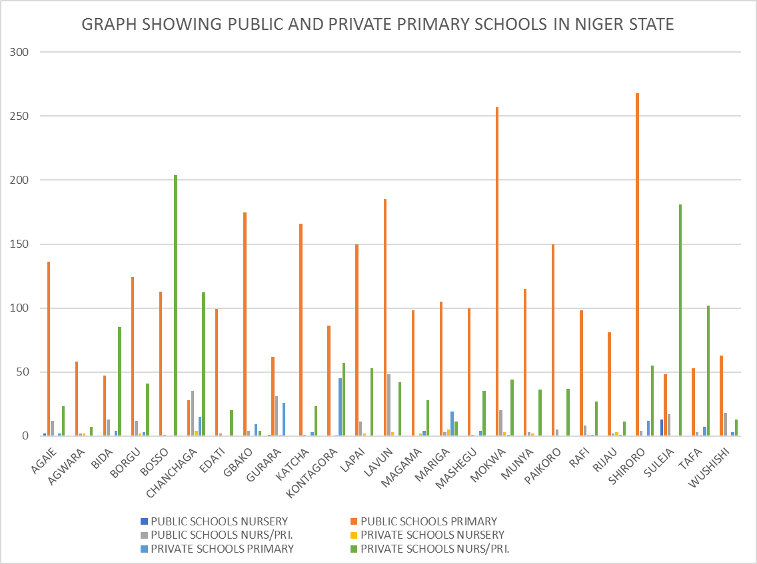

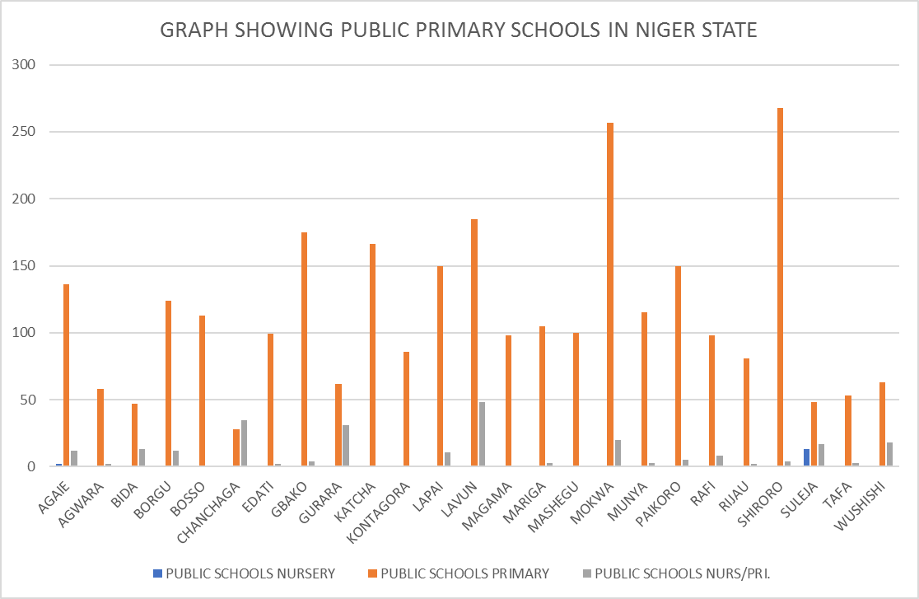

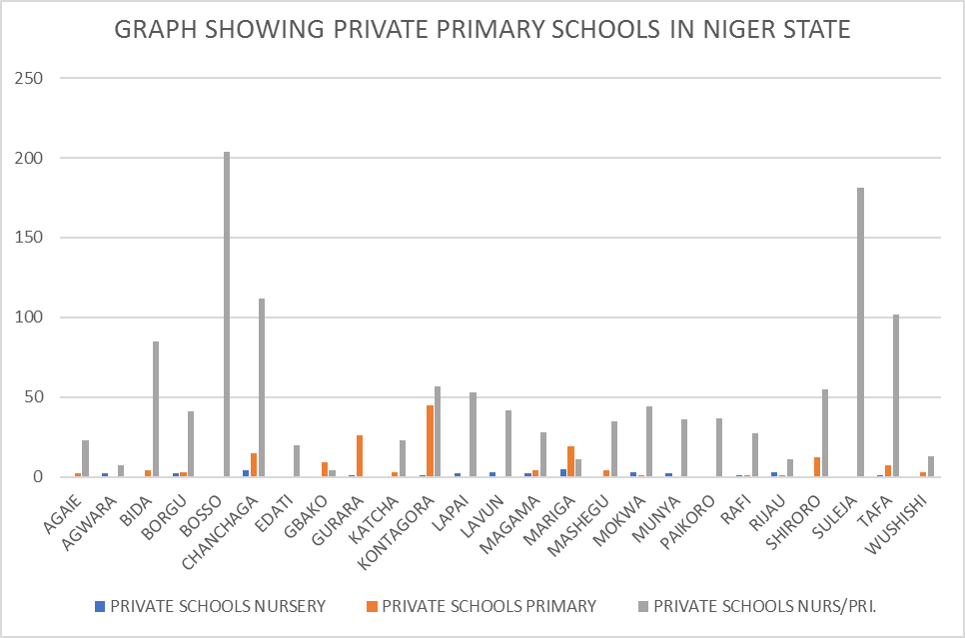

NUMBER OF NURSERY/PRIMARY SCHOOLS IN NIGER STATE BY WARD, 2022

TABLE 1.2 AGAIE LOCAL GOVERNMENT AREA
WARDS | PUBLIC SCHOOLS |  |  | PRIVATE SCHOOLS
WARDS | NURSERY | PRIMARY | NURS/PRI. | NURSERY | PRIMARY | NURS/PRI.
BARO | 1 | 19 | 3 | 0 | 0 | 3
BOKU | - | 21 | 2 | 0 | 0 | 0
EKOBADEGI | 1 | 2 | 1 | - | - | 3
ETSUGAIE | - | 21 | - | - | - | -
EKOSSA | - | 2 | - | - | - | 1
EKOWUGI | - | 1 | - | - | - | 1
EKOWUNA | - | 1 | 4 | - | 1 | 13
MAGAJI | - | 21 | - | - | - | -
KUTIRIKO | - | 14 | - | - | 1 | 2
EWUGI | - | 15 | - | - | - | -
TAGAGI | - | 19 | 2 | - | - | -
TOTAL | 2 | 136 | 12 | 0 | 2 | 23

TABLE 1.3 AGWARA LOCAL GOVERNMENT AREA
WARDS | PUBLIC SCHOOLS |  |  | PRIVATE SCHOOLS
WARDS | NURSERY | PRIMARY | NURS/PRI. | NURSERY | PRIMARY | NURS/PRI.
ADAHE | - | 4 | - | - | - | -
AGWARA | - | 7 | - | - | - | -
BUNSURU | - | 5 | - | - | - | -
GALLAH | - | 4 | 2 | - | - | 3
KASHINI | - | 8 | - | 2 | - | -
KOKOLI | - | 7 | - | - | - | -
MAGO | - | 4 | - | - | - | -
PAPIRI | - | 11 | - | - | - | 3
ROFIA | - | 4 | - | - | - | 1
SUTEKU | - | 4 | - | - | - | -
TOTAL | 0 | 58 | 2 | 2 | 0 | 7

NUMBER OF NURSERY/PRIMARY SCHOOLS IN NIGER STATE BY WARD, 2022

TABLE 1.4 BIDA LOCAL GOVERNMENT AREA
WARDS | PUBLIC SCHOOLS |  |  | PRIVATE SCHOOLS
WARDS | NURSERY | PRIMARY | NURS/PRI. | NURSERY | PRIMARY | NURS/PRI.
BARIKI | - | 3 | 1 | - | - | 17
CENIYAN | - | 8 | - | - | - | 3
DOKODZA | - | 5 | 2 | - | - | 18
KYARI | - | 6 | 2 | - | 1 | 8
LANDZU | - | 1 | - | - | - | 4
MASABA-I | - | 1 | 1 | - | - | 2
MASABA-II | - | 1 | - | - | - | 1
MASAGA-I | - | 3 | - | - | - | 5
MASAGA-II | - | 1 | - | - | - | 1
MAIYAKI-NDAJIYA | - | 2 | - | - | - | 6
NASARAFU | - | 3 | - | - | 3 | 11
UMARU-MA’AJIGI---I | - | 3 | - | - | - | 1
UMARU-MA’AJIGI--II | - | 6 | 1 | - | - | 5
WADATA | - | 4 | 6 | - | - | 3
TOTAL | 0 | 47 | 13 | 0 | 4 | 85

TABLE 1.5 BORGU LOCAL GOVERNMENT AREA
WARDS | PUBLIC SCHOOLS |  |  | PRIVATE SCHOOLS
WARDS | NURSERY | PRIMARY | NURS/PRI. | NURSERY | PRIMARY | NURS/PRI.
RAFI | - | 17 | - | - | - | 1
KARABONDE | - | 3 | 4 | - | - | 1
KONKOSO | - | 15 | - | - | - | 1
BUSSA | - | 5 | 4 | 2 | 1 | 18
MALALE | - | 9 | - | - | - | -
DUGGA | - | 8 | - | - | - | 8
BABANNA | - | 23 | 1 | - | - | 7
PISSA/KABE | - | 16 | 2 | - | - | -
SHAGUNU | - | 17 | - | - | - | 2
WAWA | - | 11 | 1 | - | 2 | 3
TOTAL | 0 | 124 | 12 | 2 | 3 | 41
NUMBER OF NURSERY/PRIMARY SCHOOLS IN NIGER STATE BY WARD, 2022

TABLE 1.6 BOSSO LOCAL GOVERNMENT AREA
WARDS | PUBLIC SCHOOLS |  |  | PRIVATE SCHOOLS
WARDS | NURSERY | PRIMARY | NURS/PRI. | NURSERY | PRIMARY | NURS/PRI.
BEJI | - | 13 | - | - | - | 7
BOSSO-CENTRAL-I | - | 6 | - | - | - | 36
BOSSO-CENTRAL-II | - | 3 | 1 | - | - | 18
CHANCHAGA | - | 9 | - | - | - | 44
GARATU | - | 17 | - | - | - | 19
KAMPALA | - | 16 | - | - | - | 1
KODO | - | 10 | - | - | - | 2
MAIKUNKELE | - | 16 | - | - | - | 24
MAITUMBI | - | 11 | - | - | - | 52
SHATTA | - | 12 | - | - | - | 1
TOTAL | 0 | 113 | 1 | 0 | 0 | 204

TABLE 1.7 CHANCHAGA LOCAL GOVERNMENT AREA
WARDS | PUBLIC SCHOOLS |  |  | PRIVATE SCHOOLS
WARDS | NURSERY | PRIMARY | NURS/PRI. | NURSERY | PRIMARY | NURS/PRI.
NASSARAWA-‘A’ | - | - | - | - | - | -
-NASSARAWA-‘B’ | - | 1 | - | - | - | 8
-NASSARAWA-‘C’ | - | 5 | - | - | - | 8
-T/WADASOUTH | - | 3 | 1 | - | - | 8
MAKERA | - | - | - | 4 | - | 5
SABONGARI | - | 1 | 1 | - | - | 13
-MINNA-CENTRAL | - | 6 | 4 | - | - | 7
-MINNA-SOUTH | - | 5 | 4 | - | - | 17
T/WADANORTH | - | - | 20 | - | - | 23
LIMAWA-‘A’ | - | 3 | 1 | - | - | 7
LIMAWA-‘B’ | - | 4 | 4 | - | 15 | 16
TOTAL | 0 | 28 | 35 | 4 | 15 | 112

NUMBER OF NURSERY/PRIMARY SCHOOLS IN NIGER STATE BY WARD, 2022

TABLE 1.8 EDATI LOCAL GOVERNMENT AREA
WARDS | PUBLIC SCHOOLS |  |  | PRIVATE SCHOOLS
WARDS | NURSERY | PRIMARY | NURS/PRI. | NURSERY | PRIMARY | NURS/PRI.
ROKOTA | - | 7 | - | - | - | 2
GAZHE-I | - | 12 | - | - | - | -
GAZHE-II | - | 9 | - | - | - | 1
GONAGI | - | 11 | 1 | - | - | 2
ENAGI | - | 10 | 1 | - | - | 5
SAKPE | - | 10 | - | - | - | 2
GUZZAN | - | 8 | - | - | - | 2
ETSU-TASHA | - | 14 | - | - | - | 3
FAZHI | - | 4 | - | - | - | -
GBAGBAN | - | 14 | - | - | - | 3
TOTAL | 0 | 99 | 2 | 0 | 0 | 20

TABLE 1.9 GBAKO LOCAL GOVERNMENT AREA
WARDS | PUBLIC SCHOOLS |  |  | PRIVATE SCHOOLS
WARDS | NURSERY | PRIMARY | NURS/PRI. | NURSERY | PRIMARY | NURS/PRI.
BATAKO | - | 21 | - | - | - | -
EDOZHIGI | - | 21 | - | - | 2 | -
ETSU-AUDU | - | 33 | - | - | - | -
GBADAFU | - | 23 | - | - | 6 | 1
EDOKOTA | - | 14 | - | - | - | -
GOGATA | - | 4 | - | - | - | -
LEMU | - | 10 | - | - | - | 2
NUWANKOTA | - | 25 | - | - | - | -
SOMMAJIKO | - | 18 | - | - | 1 | 1
BATAGI | - | 6 | 4 | - | - | -
TOTAL | 0 | 175 | 4 | 0 | 9 | 4

NUMBER OF NURSERY/PRIMARY SCHOOLS IN NIGER STATE BY WARD, 2022

TABLE 1.10 GURARA LOCAL GOVERNMENT AREA
WARDS | PUBLIC SCHOOLS |  |  | PRIVATE SCHOOLS
WARDS | NURSERY | PRIMARY | NURS/PRI. | NURSERY | PRIMARY | NURS/PRI.
BONU | 1 | 13 | 1 | 1 | - | -
DIKO | - | - | 11 | - | 3 | -
GAWU | - | - | 3 | - | 9 | -
IZOM | - | 5 | 4 | - | 5 | -
KABO | - | 10 | 1 | - | 1 | -
KWAKA | - | 7 | 2 | - | - | -
LAMBATA | - | 1 | 7 | - | 5 | -
LEFU | - | 10 | - | - | - | -
SHAKO | - | 11 | - | - | - | -
TUFA | - | 5 | 2 | - | 3 | -
TOTAL | 1 | 62 | 31 | 1 | 26 | 0

TABLE 1.11 KATCHA LOCAL GOVERNMENT AREA
WARDS | PUBLIC SCHOOLS |  |  | PRIVATE SCHOOLS
WARDS | NURSERY | PRIMARY | NURS/PRI. | NURSERY | PRIMARY | NURS/PRI.
BISANTI | - | 24 | - | - | 2 | -
BADEGGI | - | 16 | - | - | - | 6
ESSA | - | 21 | - | - | - | -
KATAEREGI | - | 19 | 1 | - | - | 8
SIDI-SABA | - | 16 | - | - | - | -
DZWAFU | - | 17 | - | - | - | -
BAKEKO | - | 16 | - | - | - | -
GBAKOGI | - | 15 | - | - | - | -
EDOTSU | - | 12 | - | - | - | 2
KATCHA | - | 10 | - | - | 1 | 7
TOTAL | 0 | 166 | 1 | 0 | 3 | 23

NUMBER OF NURSERY/PRIMARY SCHOOLS IN NIGER STATE BY WARD, 2022

TABLE 1.12 KONTAGORA LOCAL GOVERNMENT AREA
WARDS | PUBLIC SCHOOLS |  |  | PRIVATE SCHOOLS
WARDS | NURSERY | PRIMARY | NURS/PRI. | NURSERY | PRIMARY | NURS/PRI.
MASUGA | - | 29 | - | - | - | -
AREWA | - | 1 | - | - | - | 2
MADARA | - | 6 | - | 1 | 4 | -
NAGWAMATSE | - | 8 | - | - | 2 | 2
CENTRAL | - | 1 | - | - | 1 | 1
RAFIN-GORA | - | 2 | - | - | - | -
KUDU | - | 6 | - | - | 22 | 23
TUNGAN-KAWO | - | 5 | - | - | - | -
TUNGAN-WAWA | - | 9 | - | - | - | 1
USALLE | - | 6 | - | - | - | -
MAGAJIYA | - | 4 | - | - | 1 | 9
YAMMA | - | 3 | - | - | 6 | 11
GABAS | - | 6 | - | - | 9 | 8
TOTAL | 0 | 86 | 0 | 1 | 45 | 57

TABLE 1.13 LAPAI LOCAL GOVERNMENT AREA
WARDS | PUBLIC SCHOOLS |  |  | PRIVATE SCHOOLS
WARDS | NURSERY | PRIMARY | NURS/PRI. | NURSERY | PRIMARY | NURS/PRI.
GUPA ABUGI | - | 22 | - | - | - | 1
MUYE-EGBA | - | 18 | - | - | - | 4
GABAS/KUDU | - | 2 | 1 | - | - | 6
AREWA/YAMMA | - | 2 | 7 | - | - | 9
EVUTI/KPADA | - | 20 | - | - | - | 14
BIRNI MAZA/ TASHIBO | - | 19 | - | - | - | 8
TAKUTI ISHAKU | - | 29 | - | - | - | 3
EBBO/GBACINKU | - | 15 | - | - | - | 3
DUMA/ZAGO | - | 10 | - | - | - | 3
GULU ANGUWA /GULUVATSA | - | 13 | 3 | 2 | - | 2
TOTAL | 0 | 150 | 11 | 2 | 0 | 53

NUMBER OF NURSERY/PRIMARY SCHOOLS IN NIGER STATE BY WARD, 2022

TABLE 1.14 LAVUN LOCAL GOVERNMENT AREA
WARDS | PUBLIC SCHOOLS |  |  | PRIVATE SCHOOLS
WARDS | NURSERY | PRIMARY | NURS/PRI. | NURSERY | PRIMARY | NURS/PRI.
BUSU | - | 4 | 24 | - | - | 3
BATATI | - | 3 | 14 | - | - | 6
DASSUN | - | 24 | - | - | - | 5
DOKO | - | 19 | 1 | - | - | 6
DABBAN | - | 8 | 4 | - | - | 1
EGBAKO | - | 19 | - | 3 | - | -
GABA | - | 19 | - | - | - | 1
JIMA | - | 14 | - | - | - | 6
KUTIGI | - | 7 | 4 | - | - | 8
KUSOTACHI | - | 26 | - | - | - | 6
LAGUN | - | 18 | - | - | - | -
MANBE | - | 24 | 1 | - | - | -
TOTAL | 0 | 185 | 48 | 3 | 0 | 42

TABLE 1.15 MAGAMA LOCAL GOVERNMENT AREA
WARDS | PUBLIC SCHOOLS |  |  | PRIVATE SCHOOLS
WARDS | NURSERY | PRIMARY | NURS/PRI. | NURSERY | PRIMARY | NURS/PRI.
NASKO | - | 9 | - | - | - | 2
IBELU-CENTRAL | - | 8 | - | - | - | 8
IBELU-NORTH | - | 5 | - | - | - | 1
IBELU-EAST | - | 10 | - | - | - | 1
IBELU-WEST | - | 8 | - | - | - | -
AUNA-CENTRAL | - | 6 | - | 2 | 3 | 4
AUNA-EAST | - | 12 | - | - | - | -
SALKA-CENTRAL- | - | 10 | - | - | - | 10
KAWO | - | 16 | - | - | - | 1
NASSARAWA | - | 8 | - | - | 1 | 1
TUNGA-JIKA | - | 6 | - | - | - | -
TOTAL | 0 | 98 | 0 | 2 | 4 | 28

NUMBER OF NURSERY/PRIMARY SCHOOLS IN NIGER STATE BY WARD, 2022

TABLE 1.16 MARIGA LOCAL GOVERNMENT AREA
WARDS | PUBLIC SCHOOLS |  |  | PRIVATE SCHOOLS
WARDS | NURSERY | PRIMARY | NURS/PRI. | NURSERY | PRIMARY | NURS/PRI.
INKWAI | - | 4 | 2 | 2 | 6 | 2
BERI | - | 7 | - | - | 2 | 1
GALMA-WAMBA | - | 10 | - | - | - | -
MABURYA | 0 | 8 | - | - | 2 | -
KUMBASHI | - | 8 | - | - | - | -
BANGI | - | 7 | 1 | - | 3 | 3
BOBI | - | 11 | - | 3 | - | 1
G/BOKA | - | 19 | - | - | 6 | 1
KAKIHUM | - | 8 | - | - | - | -
KOTONKORO | - | 15 | - | - | - | 3
IGWAMA | - | 8 | - | - | - | -
TOTAL | 0 | 105 | 3 | 5 | 19 | 11

TABLE 1.17 MASHEGU LOCAL GOVERNMENT AREA
WARDS | PUBLIC SCHOOLS |  |  | PRIVATE SCHOOLS
WARDS | NURSERY | PRIMARY | NURS/PRI. | NURSERY | PRIMARY | NURS/PRI.
SAHON-RAMI | - | 6 | - | - | - | 4
MASHEGU | - | 11 | - | - | - | 5
KASANGA | - | 18 | - | - | - | 3
MAZAKUKA | - | 7 | - | - | - | -
KABOJI | - | 7 | - | - | - | 3
IBBI | - | 12 | - | - | - | 13
DAFAGI/MAKERA | - | 15 | - | - | - | 2
KWATACHI | - | 5 | - | - | - | 4
BABBAN-RAMI | - | 10 | - | - | 4 | 1
KULHO | - | 9 | 1 | - | - | -
TOTAL | 0 | 100 | 1 | 0 | 4 | 35

NUMBER OF NURSERY/PRIMARY SCHOOLS IN NIGER STATE BY WARD, 2022

TABLE 1.18 MOKWA LOCAL GOVERNMENT AREA
WARDS | PUBLIC SCHOOLS |  |  | PRIVATE SCHOOLS
WARDS | NURSERY | PRIMARY | NURS/PRI. | NURSERY | PRIMARY | NURS/PRI.
BOKANI | - | 19 | 1 | - | - | 1
MUWO/GBAJIBO | - | 23 | - | 1 | - | 4
GBARA | - | 39 | - | - | - | 1
JA’AGI | - | 28 | - | 2 | - | -
JEBBA | - | 24 | 2 | - | 1 | 5
KPAKI | - | 19 | 1 | - | - | 2
KUDU | - | 11 | - | - | - | 4
LABOZHI | - | 16 | - | - | - | 2
MOKWA-CENTRAL | - | 4 | 13 | - | - | 22
MUREGI | - | 46 | - | - | - | -
RABBA/NDAYAKO | - | 28 | 3 | - | - | 3
TOTAL | 0 | 257 | 20 | 3 | 1 | 44

TABLE 1.19 MUNYA LOCAL GOVERNMENT AREA
WARDS | PUBLIC SCHOOLS |  |  | PRIVATE SCHOOLS
WARDS | NURSERY | PRIMARY | NURS/PRI. | NURSERY | PRIMARY | NURS/PRI.
FUKA | - | 6 | - | - | - | 1
DANGUNU | - | 8 | 1 | 1 | - | 9
KABULA | - | 15 | 1 | - | - | 4
KUNCHI | - | 22 | - | 1 | - | 3
GINI | - | 9 | - | - | - | 2
DAZA | - | 11 | - | - | - | 4
BENI | - | 5 | - | - | - | -
KAZAI | - | 5 | - | - | - | -
GUNI | - | 14 | - | - | - | 3
SARKIN-PAWA | - | 14 | - | - | - | 3
DAN-DAUDU | - | 6 | 1 | - | - | 7
TOTAL | 0 | 115 | 3 | 2 | 0 | 36
NUMBER OF NURSERY/PRIMARY SCHOOLS IN NIGER STATE BY WARD, 2022

TABLE 1.20 PAIKORO LOCAL GOVERNMENT AREA
WARDS | PUBLIC SCHOOLS |  |  | PRIVATE SCHOOLS
WARDS | NURSERY | PRIMARY | NURS/PRI. | NURSERY | PRIMARY | NURS/PRI.
ADUNU | - | 6 | - | - | - | 2
CHIMBI | - | 9 | - | - | - | 3
GWAM | - | 15 | - | - | - | -
ISHAU | - | 14 | - | - | - | -
JERE | - | 10 | - | - | - | -
KAFINKORO | - | 20 | - | - | - | 10
KWANGANA | - | 15 | - | - | - | 1
KWAKUTI | - | 12 | - | - | - | 6
NIKUCHI/T/-MALLAM | - | 25 | - | - | - | -
PAIKO-CENTRAL- | - | 3 | 4 | - | - | 10
TUTUNGO | - | 21 | 1 | - | - | 5
TOTAL | 0 | 150 | 5 | 0 | 0 | 37

TABLE 1.21 RAFI LOCAL GOVERNMENT AREA
WARDS | PUBLIC SCHOOLS |  |  | PRIVATE SCHOOLS
WARDS | NURSERY | PRIMARY | NURS/PRI. | NURSERY | PRIMARY | NURS/PRI.
KAGARA-GARI | - | 9 | - | - | - | 4
KAKURI-(Madaka) | - | 10 | - | - | - | -
KONGOMA-CENTRAL | - | 8 | 4 | - | 1 | 6
KONGOMA- | - | 5 | - | - | - | 1
KUSHERKI-NORTH | - | 12 | - | - | - | 3
KUSHERKI-SOUTH | - | 13 | - | - | - | -
KUNDU | - | 6 | 1 | - | - | -
SABON-GARI | - | 12 | - | - | - | 5
TEGINA-GARI | - | 5 | 3 | 1 | - | 5
TEGINA-WEST | - | 9 | - | - | - | 2
YAKILA-(Gunna) | - | 9 | - | - | - | 1
TOTAL | 0 | 98 | 8 | 1 | 1 | 27

NUMBER OF NURSERY/PRIMARY SCHOOLS IN NIGER STATE BY WARD, 2022

TABLE 1.22 RIJAU LOCAL GOVERNMENT AREA
WARDS | PUBLIC SCHOOLS |  |  | PRIVATE SCHOOLS
WARDS | NURSERY | PRIMARY | NURS/PRI. | NURSERY | PRIMARY | NURS/PRI.
DANRANGI | - | 10 | - | - | - | -
DUGGE | - | 4 | - | - | - | -
DUKKU | - | 13 | - | 1 | - | -
GENU- | - | 7 | - | - | - | -
JAMA’ARE | - | 5 | - | - | - | -
RIJAU | - | 7 | 2 | - | - | 8
SHAMBO | - | 3 | - | - | - | -
TUNGAN-BUNU | - | 6 | - | - | - | -
T/-MAGAJIYA | - | 9 | - | - | - | 3
S/-GARIN-USHE | - | 8 | - | - | - | -
WARARI | - | 9 | - | 2 | 1 | -
TOTAL | 0 | 81 | 2 | 3 | 1 | 11

TABLE 1.23 SHIRORO LOCAL GOVERNMENT AREA
WARDS | PUBLIC SCHOOLS |  |  | PRIVATE SCHOOLS
WARDS | NURSERY | PRIMARY | NURS/PRI. | NURSERY | PRIMARY | NURS/PRI.
GALKOGO | - | 13 | - | - | - | -
ERENA | - | 18 | 2 | - | 2 | 3
KWAKI/CHUKUBA | - | 9 | - | - | - | -
GURMANA | - | 9 | - | - | - | -
ALLAWA | - | 10 | - | - | - | -
BANGAJIYA | - | 25 | - | - | - | 11
GUSSORO | - | 30 | - | - | 4 | 6
UBANDOMA | - | 24 | 1 | - | - | 9
EGWA/GWADA | - | 28 | - | - | 6 | 21
PINA | - | 21 | - | - | - | 1
KATO | - | 16 | - | - | - | -
SHE | - | 27 | - | - | - | 4
BASSA/KUKOKI | - | 16 | 1 | - | - | -
KUREBE/KUSHAKA | - | 13 | - | - | - | -
MANTA | - | 9 | - | - | - | -
TOTAL | 0 | 268 | 4 | 0 | 12 | 55
NUMBER OF NURSERY/PRIMARY SCHOOLS IN NIGER STATE BY WARD, 2022

TABLE 1.24 SULEJA LOCAL GOVERNMENT AREA
WARDS | PUBLIC SCHOOLS |  |  | PRIVATE SCHOOLS
WARDS | NURSERY | PRIMARY | NURS/PRI. | NURSERY | PRIMARY | NURS/PRI.
BAGAMA-‘A’ | 1 | 3 | 6 | - | - | 15
BAGAMA-‘B’ | 1 | 2 | 1 | - | - | 11
MAGAJIYA | 4 | - | - | - | - | 2
IKU-SOUTH—I | - | 9 | 1 | - | - | 35
IKU-SOUTH-II | - | 8 | - | - | - | 34
HASHIMI-‘A’ | - | 8 | - | - | - | 6
HASHIMI-‘B’ | 1 | - | 2 | - | - | 7
MAJE | - | 12 | 3 | - | - | 45
KURMIN-SARKI | 1 | 6 | 1 | - | - | 23
WAMBAI | 5 | - | 3 | - | - | 3
TOTAL | 13 | 48 | 17 | 0 | 0 | 181

TABLE 1.25 TAFA LOCAL GOVERNMENT AREA
WARDS | PUBLIC SCHOOLS |  |  | PRIVATE SCHOOLS
WARDS | NURSERY | PRIMARY | NURS/PRI. | NURSERY | PRIMARY | NURS/PRI.
DOGON-KURMI | - | 3 | 3 | - | 3 | 5
NEW-BWARI | - | 5 | - | - | - | 7
ZUMA-WEST | - | 6 | - | - | 1 | 23
ZUMA-EAST | - | 3 | - | - | - | 22
WUSE-WEST | - | 2 | - | - | 3 | 7
WUSE-EAST- | - | 7 | - | - | - | 9
IKU | - | 10 | - | - | - | 16
IJA-KORO | - | 5 | - | 1 | - | -
IJA-GBAGYI | - | 7 | - | - | - | 2
GARAM | - | 5 | - | - | - | 11
TOTAL | 0 | 53 | 3 | 1 | 7 | 102

NUMBER OF NURSERY/PRIMARY SCHOOLS IN NIGER STATE BY WARD, 2022

TABLE 1.26 WUSHISHI LOCAL GOVERNMENT AREA
WARDS | PUBLIC SCHOOLS |  |  | PRIVATE SCHOOLS
WARDS | NURSERY | PRIMARY | NURS/PRI. | NURSERY | PRIMARY | NURS/PRI.
SABON-GARI | - | 4 | - | - | - | 12
KWATA | - | 5 | 2 | - | - | -
BARWA | - | - | 1 | - | 1 | 2
LOKOGOMA | - | 7 | - | - | - | -
MAITO | - | 4 | - | - | - | 2
KODO | - | 7 | 3 | - | - | 1
GWARJIKO | - | 7 | 7 | - | 2 | -
ZUNGERU | - | 9 | 4 | - | - | 10
T/YAMIGI | - | 12 | - | - | - | -
AKARE | - | 8 | - | - | - | -
KANWURI | - | - | 1 | - | - | -
TOTAL | 0 | 63 | 18 | 0 | 3 | 27

CHAPTER TWO
EDUCATION - Secondary Schools In Niger State, 2022
Table 2.1 provides information on the number of public and private Secondary Schools (JSS only, SSS only and (JSS/SSS) in Niger State by LGA for the year 2022 while the same information by ward for each of the 25 LGA of the state are contained in Table 2.2 – 2.26 below.
A total of 975 public and private Secondary Schools were recorded for the period under review. This is made up of 557 (57.13%) public Secondary Schools and 418 (42.87%) private Secondary Schools. Mokwa LGA has the highest number of public Secondary Schools (49) followed by Katcha LGA with 37 while the least number of public Secondary Schools (5) was recorded in Agwara LGA. Similarly, the highest number of private Secondary Schools (66) was recorded in Bosso LGA followed by Chanchaga LGA with (64) Schools. Only one (1) private Secondary Schools each was recorded in Agwara, Edati and Gbako LGAs.

TABLE 2.1
NUMBER OF SECONDARY SCHOOLS IN NIGER STATE BY LGA, 2022

LGA | PUBLIC SCHOOLS |  |  |  | PRIVATE SCHOOLS |  |  |  | GRAND TOTAL
LGA | JSS ONLY | SSS ONLY | JSS/SSS | TOTAL | JSS ONLY | SSS ONLY | JSS/SSS | TOTAL | GRAND TOTAL
AGAIE | 8 | 1 | 8 | 17 | 4 | 1 | 5 | 10 | 27
AGWARA | 0 | 0 | 5 | 5 | 0 | 0 | 1 | 1 | 6
BIDA | 5 | 0 | 17 | 22 | 14 | 0 | 16 | 30 | 52
BORGU | 6 | 1 | 13 | 20 | 6 | 1 | 14 | 21 | 41
BOSSO | 6 | 2 | 27 | 35 | 25 | 5 | 36 | 66 | 101
CHANCHAGA | 7 | 3 | 10 | 20 | 37 | 1 | 26 | 64 | 84
EDATI | 6 | 0 | 8 | 14 | 1 | 0 | 0 | 1 | 15
GBAKO | 10 | 0 | 6 | 16 | 1 | 0 | 0 | 1 | 17
GURARA | 7 | 1 | 11 | 19 | 3 | 0 | 0 | 3 | 22
KATCHA | 19 | 2 | 16 | 37 | 6 | 1 | 5 | 12 | 49
KONTAGORA | 17 | 0 | 16 | 33 | 4 | 0 | 13 | 17 | 50
LAPAI | 6 | 1 | 19 | 26 | 0 | 0 | 4 | 4 | 30
LAVUN | 14 | 1 | 16 | 31 | 8 | 0 | 1 | 9 | 40
MAGAMA | 8 | 0 | 11 | 19 | 7 | 0 | 0 | 7 | 26
MARIGA | 8 | 0 | 7 | 15 | 8 | 0 | 0 | 8 | 23
MASHEGU | 14 | 0 | 4 | 18 | 5 | 0 | 1 | 6 | 24
MOKWA | 11 | 6 | 32 | 49 | 2 | 1 | 17 | 20 | 69
MUNYA | 6 | 0 | 5 | 11 | 3 | 0 | 3 | 6 | 17
PAIKORO | 7 | 0 | 16 | 23 | 1 | 0 | 5 | 6 | 29
RAFI | 4 | 2 | 13 | 19 | 3 | 1 | 5 | 9 | 28
RIJAU | 8 | 1 | 4 | 13 | 3 | 0 | 7 | 10 | 23
SHIRORO | 11 | 1 | 18 | 30 | 5 | 0 | 5 | 10 | 40
SULEJA | 10 | 1 | 16 | 27 | 10 | 1 | 32 | 43 | 70
TAFA | 7 | 5 | 6 | 18 | 5 | 2 | 32 | 39 | 57
WUSHISHI | 11 | 1 | 8 | 20 | 10 | 0 | 5 | 15 | 35
TOTAL | 215 | 29 | 312 | 557 | 171 | 14 | 233 | 418 | 975

Figure 2: GRAPH SHOWING SECONDARY SCHOOLS IN NIGER STATE BY LGA, 2022

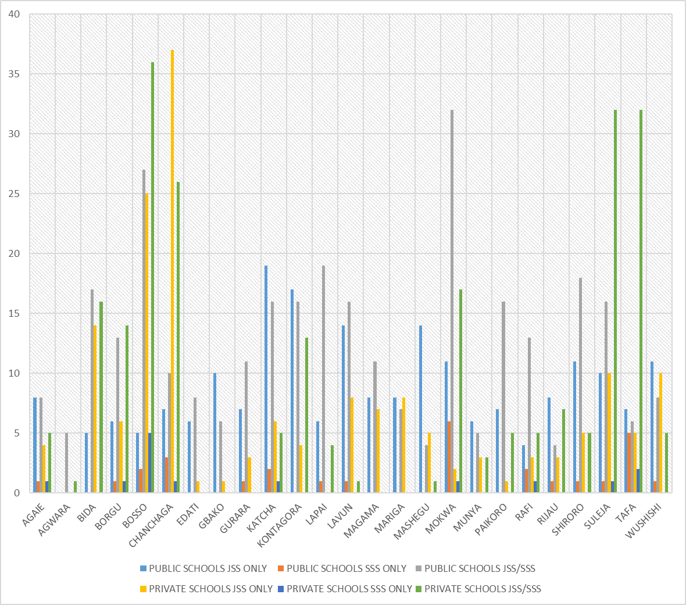
NUMBER OF SECONDARY SCHOOLS IN NIGER STATE BY WARD, 2022

TABLE 2.2 AGAIE LOCAL GOVERNMENT AREAS
WARDS | PUBLIC SCHOOLS |  |  | PRIVATE SCHOOLS
WARDS | JSS ONLY | SSS ONLY | JSS/SSS | JSS ONLY | SSS ONLY | JSS/SSS
BARO | 1 |  | 1
BOKU | 3
EKOBADEGI |  |  | 1
ETSUGAIE | 1 | 1
EKOSSA |  |  | 1
EKOWUGI |  |  | 2
EKOWUNA | 1 |  |  | 4 | 1 | 5
MAGAJI | 1
KUTIRIKO | 1 |  | 1
EWUGI
TAGAGI |  |  | 2
TOTAL | 8 | 1 | 8 | 4 | 1 | 5

TABLE 2.3 AGWARA LOCAL GOVERNMENT AREA

WARDS | PUBLIC SCHOOLS |  |  | PRIVATE SCHOOLS
WARDS | JSS ONLY | SSS ONLY | JSS/SSS | JSS ONLY | SSS ONLY | JSS/SSS
ADAHE
AGWARA
BUNSURU
GALLAH |  |  | 1
KASHINI |  |  | 1
KOKOLI
MAGO |  |  | 1
PAPIRI |  |  | 1 |  |  | 1
ROFIA |  |  | 1
SUTEKU
TOTAL | 0 | 0 | 5 | 0 | 0 | 1

NUMBER OF SECONDARY SCHOOLS IN NIGER STATE BY WARD, 2022

TABLE 2.4 BIDA LOCAL GOVERNMENT AREA
WARDS |  | PUBLIC SCHOOLS |  |  |  |  |  | PRIVATE SCHOOLS
 |  | JSS ONLY |  | SSS ONLY |  | JSS/SSS |  | JSS ONLY |  | SSS ONLY |  | JSS/SSS
BARIKI |  | 1 |  | - |  | 2 |  | 1 |  | - |  | 2
CENIYAN |  | - |  | - |  | 6 |  | 5 |  | - |  | 4
DOKODZA |  | - |  | - |  | 1 |  | 1 |  | - |  | 4
KYARI |  | - |  | - |  | - |  | 2 |  | - |  | -
LANDZU |  | - |  | - |  | - |  | - |  | - |  | -
MASABA-I |  | - |  | - |  | - |  | 2 |  | - |  | 1
MASABA-II |  | 1 |  | - |  | - |  | - |  | - |  | -
MASAGA-I |  | - |  | - |  | - |  | - |  | - |  | -
MASAGA-II |  | - |  | - |  | - |  | - |  | - |  | -
MAIYAKI-NDAJIYA |  | - |  | - |  | - |  | - |  | - |  | -
NASARAFU |  | 1 |  | - |  | 5 |  | 2 |  | - |  | 5
UMARU-MA’AJIGI---I |  | - |  | - |  | - |  | - |  | - |  | -
UMARU-MA’AJIGI—II |  | 1 |  | - |  | - |  | - |  | - |  | -
WADATA |  | 1 |  | - |  | 3 |  | 1 |  | - |  | -
TOTAL |  | 5 |  | 0 |  | 17 |  | 14 |  | 0 |  | 16
TABLE 2.5 BORGU LOCAL GOVERNMENT AREA
WARDS | PUBLIC SCHOOLS |  |  |  |  |  | PRIVATE SCHOOLS
WARDS | JSS ONLY |  | SSS ONLY |  | JSS/SSS |  | JSS ONLY |  | SSS ONLY |  | JSS/SSS
RAFI | 1 |  | - |  | 2 |  | 1 |  | - |  | -
KARABONDE | - |  | - |  | 1 |  | - |  | - |  | 1
KONKOSO | - |  | - |  | 1 |  | - |  | - |  | -
BUSSA | 2 |  | 1 |  | 1 |  | 4 |  | 1 |  | 8
MALALE | - |  | - |  | - |  | - |  | - |  | -
DUGGA | - |  | - |  | 1 |  | 1 |  | - |  | 2
BABANNA | 1 |  | - |  | 2 |  | - |  | - |  | 3
PISSA/KABE | 1 |  | - |  | 2 |  | - |  | - |  | -
SHAGUNU | 1 |  | - |  | 1 |  | - |  | - |  | -
WAWA | - |  | - |  | 2 |  | - |  | - |  | -
TOTAL | 6 |  | 1 |  | 13 |  | 6 |  | 1 |  | 14
NUMBER OF SECONDARY SCHOOLS IN NIGER STATE BY WARD, 2022

TABLE 2.6 BOSSO LOCAL GOVERNMENT AREA
WARDS | PUBLIC SCHOOLS |  |  | PRIVATE SCHOOLS
WARDS | JSS ONLY | SSS ONLY | JSS/SSS | JSS ONLY | SSS ONLY | JSS/SSS
BEJI | - | - | 1 | - | 2 | -
BOSSO-CENTRAL-I | 1 | 1 | 5 | - | - | 17
BOSSO-CENTRAL-II | - | - | 2 | - | 2 | 4
CHANCHAGA | 1 | - | 7 | 9 | 1 | 2
GARATU | - | - | 2 | 5 | - | 2
KAMPALA | - | - | 1 | - | - | -
KODO | 1 | - | 1 | - | - | -
MAIKUNKELE | - | - | 3 | 2 | - | 5
MAITUMBI | 2 | - | 2 | 9 | - | 6
SHATTA | 1 | 1 | 3 | - | - | -
TOTAL | 6 | 2 | 27 | 25 | 5 | 36

TABLE 2.7 CHANCHAGA LOCAL GOVERNMENT AREA
WARDS | PUBLIC SCHOOLS |  |  | PRIVATE SCHOOLS
WARDS | JSS ONLY | SSS ONLY | JSS/SSS | JSS ONLY | SSS ONLY | JSS/SSS
NASSARAWA-‘A’ | - | - | - | - | - | -
NASSARAWA-‘B’ | - | - | - | 3 | - | 4
NASSARAWA-‘C’ | - | - | 2 | 1 | - | 4
T/WADASOUTH | 1 | - | 1 | 6 | - | 3
MAKERA | - | - | - | 3 | - | -
SABONGARI | 1 | 1 | 1 | 1 | - | 2
MINNA-CENTRAL | - | - | - | - | - | -
MINNA-SOUTH | 2 | - | - | 7 | - | 4
T/WADANORTH | - | - | - | 8 | - | 3
LIMAWA-‘A’ | - | 1 | 4 | - | - | 1
LIMAWA-‘B’ | 3 | 1 | 2 | 8 | 1 | 5
TOTAL | 7 | 3 | 10 | 37 | 1 | 26

NUMBER OF SECONDARY SCHOOLS IN NIGER STATE BY WARD, 2022

TABLE 2.8 EDATI LOCAL GOVERNMENT AREA
WARDS | PUBLIC SCHOOLS |  |  | PRIVATE SCHOOLS
WARDS | JSS ONLY | SSS ONLY | JSS/SSS | JSS ONLY | SSS ONLY | JSS/SSS
ROKOTA | 2 | - | - | - | - | -
GAZHE-I | - | - | - | - | - | -
GAZHE-II | 1 | - | - | - | - | -
GONAGI | - | - | 2 | - | - | -
ENAGI | - | - | 1 | 1 | - | -
SAKPE | - | - | 2 | - | - | -
GUZZAN | - | - | 2 | - | - | -
ETSU-TASHA | 2 | - | - | - | - | -
FAZHI | 1 | - | - | - | - | -
GBAGBAN | - | - | 1 | - | - | -
TOTAL | 6 | 0 | 8 | 1 | 0 | 0

TABLE 2.9 GBAKO LOCAL GOVERNMENT AREA
WARDS | PUBLIC SCHOOLS |  |  | PRIVATE SCHOOLS
WARDS | JSS ONLY | SSS ONLY | JSS/SSS | JSS ONLY | SSS ONLY | JSS/SSS
BATAKO | 1 | - | - | - | - | -
EDOZHIGI | 1 | - | 1 | - | - | -
ETSU-AUDU | 1 | - | - | - | - | -
GBADAFU | 2 | - | 1 | - | - | -
EDOKOTA | 2 | - | - | - | - | -
GOGATA | - | - | - | - | - | -
LEMU | - | - | 2 | 1 | - | -
NUWANKOTA | 3 | - | - | - | - | -
SOMMAJIKO | - | - | 1 | - | - | -
BATAGI | - | - | 1 | - | - | -
TOTAL | 10 | 0 | 6 | 1 | 0 | 0

NUMBER OF SECONDARY SCHOOLS IN NIGER STATE BY WARD, 2022
TABLE 2.10 GURARA LOCAL GOVERNMENT AREA
WARDS | PUBLIC SCHOOLS |  |  | PRIVATE SCHOOLS
WARDS | JSS ONLY | SSS ONLY | JSS/SSS | JSS ONLY | SSS ONLY | JSS/SSS
BONU | - | - | 1 | - | - | -
DIKO | 1 | - | 2 | - | - | -
GAWU | - | - | 1 | - | - | -
IZOM | - | 1 | 2 | 2 | - | -
KABO | 3 | - | 1 | - | - | -
KWAKA | 2 | - | - | - | - | -
LAMBATA | - | - | 1 | 1 | - | -
LEFU | - | - | 1 | - | - | -
SHAKO | 1 | - | - | - | - | -
TUFA | - | - | 2 | - | - | -
TOTAL | 7 | 1 | 11 | 3 | 0 | 0

TABLE2.11 KATCHA LOCAL GOVERNMENT AREA
WARDS | PUBLIC SCHOOLS |  |  | PRIVATE SCHOOLS
WARDS | JSS ONLY | SSS ONLY | JSS/SSS | JSS ONLY | SSS ONLY | JSS/SSS
BISANTI | 2 | - | 2 | - | - | -
BADEGGI | 2 | - | 1 | - | - | 4
ESSA | 2 | - | 1 | - | - | -
KATAEREGI | 3 | - | 1 | 1 | - | -
SIDI-SABA | 4 | - | 1 | - | - | -
DZWAFU | - | - | 2 | - | - | -
BAKEKO | 3 | 2 | 1 | - | - | -
GBAKOGI | 2 | - | 1 | - | - | -
EDOTSU | 1 | - | - | 1 | - | -
KATCHA | - | - | 6 | 4 | 1 | 1
TOTAL | 19 | 2 | 16 | 6 | 1 | 5
NUMBER OF SECONDARY SCHOOLS IN NIGER STATE BY WARD, 2022

TABLE 2.12 KONTAGORA LOCAL GOVERNMENT AREA
WARDS |  | PUBLIC SCHOOLS |  |  |  |  |  | PRIVATE SCHOOLS
 |  | JSS ONLY |  | SSS ONLY |  | JSS/SSS |  | JSS ONLY |  | SSS ONLY |  | JSS/SSS
MASUGA |  | 2 |  | - |  | - |  | - |  | - |  | -
AREWA |  | - |  | - |  | 1 |  | - |  | - |  | -
MADARA |  | 3 |  | - |  | - |  | - |  | - |  | -
NAGWAMATSE |  | 1 |  | - |  | - |  | - |  | - |  | 1
CENTRAL |  | 1 |  | - |  | - |  | - |  | - |  | -
RAFIN-GORA |  | - |  | - |  | - |  | - |  | - |  | -
KUDU |  | - |  | - |  | 4 |  | - |  | - |  | 5
TUNGAN-KAWO |  | 2 |  | - |  | 1 |  | - |  | - |  | -
TUNGAN-WAWA |  | 2 |  | - |  | 2 |  | - |  | - |  | -
USALLE |  | 1 |  | - |  | - |  | - |  | - |  | -
MAGAJIYA |  | 3 |  | - |  | 1 |  | - |  | - |  | 2
YAMMA |  | 2 |  | - |  | 1 |  | 4 |  | - |  | 2
GABAS |  | - |  | - |  | 6 |  | - |  | - |  | 3
TOTAL |  | 17 |  | 0 |  | 16 |  | 4 |  | 0 |  | 13
TABLE 2.13 LAPAI LOCAL GOVERNMENT AREA
WARDS | PUBLIC SCHOOLS |  |  |  |  |  | PRIVATE SCHOOLS
WARDS | JSS ONLY |  | SSS ONLY |  | JSS/SSS |  | JSS ONLY |  | SSS ONLY |  | JSS/SSS
GUPA ABUGI | 1 |  | - |  | 2 |  | - |  | - |  | -
MUYE-EGBA | 1 |  | - |  | 1 |  | - |  | - |  | 1
GABAS/KUDU | - |  | - |  | 2 |  | - |  | - |  | -
AREWA/YAMMA | - |  | - |  | 2 |  | - |  | - |  | 2
EVUTI/KPADA | 2 |  | - |  | 1 |  | - |  | - |  | 1
BIRNI MAZA/ TASHIBO | 1 |  | - |  | 1 |  | - |  | - |  | -
TAKUTI ISHAKU | - |  | - |  | 5 |  | - |  | - |  | -
EBBO/GBACINKU | - |  | - |  | 2 |  | - |  | - |  | -
DUMA/ZAGO | 1 |  |  |  | 1 |  | - |  | - |  | -
GULU ANGUWA /GULUVATSA | - |  | 1 |  | 2 |  | - |  | - |  | -
TOTAL | 6 |  | 1 |  | 19 |  | 0 |  | 0 |  | 4
NUMBER OF SECONDARY SCHOOLS IN NIGER STATE BY WARD, 2022

TABLE 2.14 LAVUN LOCAL GOVERNMENT AREA
WARDS | PUBLIC SCHOOLS |  |  | PRIVATE SCHOOLS
WARDS | JSS ONLY | SSS ONLY | JSS/SSS | JSS ONLY | SSS ONLY | JSS/SSS
BUSU | - | - | 1 | - | - | -
BATATI | 1 | - | 3 | - | - | -
DASSUN | 4 | - | 1 | - | - | -
DOKO | - | - | 2 | - | - | 1
DABBAN | - | - | 1 | - | - | -
EGBAKO | 1 | - | 1 | - | - | -
GABA | - | - | 1 | - | - | -
JIMA | 2 | - | 1 | - | - | -
KUTIGI | - | 1 | 2 | 8 | - | -
KUSOTACHI | 2 | - | 2 | - | - | -
LAGUN | 1 | - | - | - | - | -
MANBE | 3 | - | 1 | - | - | -
TOTAL | 14 | 1 | 16 | 8 | 0 | 1

TABLE 2.15 MAGAMA LOCAL GOVERNMENT AREA
WARDS | PUBLIC SCHOOLS |  |  | PRIVATE SCHOOLS
WARDS | JSS ONLY | SSS ONLY | JSS/SSS | JSS ONLY | SSS ONLY | JSS/SSS
NASKO | 1 | - | 1 | 1 | - | -
IBELU-CENTRAL | - | - | 1 | 3 | - | -
IBELU-NORTH | - | - | - | - | - | -
IBELU-EAST | 1 | - | - | - | - | -
IBELU-WEST | - | - | 2 | - | - | -
AUNA-CENTRAL | - | - | 1 | 1 | - | -
AUNA-EAST | 2 | - | - | - | - | -
SALKA-CENTRAL- | 1 | - | 2 | 2 | - | -
KAWO | 1 | - | 2 | - | - | -
NASSARAWA | 1 | - | 1 | - | - | -
TUNGA-JIKA | 1 | - | 1 | - | - | -
TOTAL | 8 | 0 | 11 | 7 | 0 | 0

NUMBER OF SECONDARY SCHOOLS IN NIGER STATE BY WARD, 2022

TABLE 2.16 MARIGA LOCAL GOVERNMENT AREA
WARDS | PUBLIC SCHOOLS |  |  | PRIVATE SCHOOLS
WARDS | JSS ONLY | SSS ONLY | JSS/SSS | JSS ONLY | SSS ONLY | JSS/SSS
INKWAI | - | - | 2 | 2 | - | -
BERI | 1 | - | - | - | - | -
GALMA-WAMBA | 1 | - | - | - | - | -
MABURYA | 1 | - | - | - | - | -
KUMBASHI | 1 | - | - | - | - | -
BANGI | 1 | - | 1 | 1 | - | -
BOBI | - | - | 2 | 3 | - | -
G/BOKA | 1 | - | 1 | 2 | - | -
KAKIHUM | 1 | - | - | - | - | -
KOTONKORO | - | - | 1 | - | - | -
IGWAMA | 1 | - | - | - | - | -
TOTAL | 8 | 0 | 7 | 8 | 0 | 0

TABLE 2.17 MASHEGU LOCAL GOVERNMENT AREA
WARDS | PUBLIC SCHOOLS |  |  | PRIVATE SCHOOLS
WARDS | JSS ONLY | SSS ONLY | JSS/SSS | JSS ONLY | SSS ONLY | JSS/SSS
SAHON-RAMI | - | - | 1 | 1 | - | -
MASHEGU | 2 | - | 1 | 1 | - | -
KASANGA | 2 | - | - | - | - | -
MAZAKUKA | 1 | - | - | - | - | -
KABOJI | - | - | 1 | 1 | - | -
IBBI | 1 | - | 1 | 2 | - | 1
DAFAGI/MAKERA | 4 | - | - | - | - | -
KWATACHI | 2 | - | - | - | - | -
BABBAN-RAMI | 1 | - | - | - | - | -
KULHO | 1 | - | - | - | - | -
TOTAL | 14 | 0 | 4 | 5 | 0 | 1

NUMBER OF SECONDARY SCHOOLS IN NIGER STATE BY WARD, 2022

TABLE 2.18 MOKWA LOCAL GOVERNMENT AREA
WARDS | PUBLIC SCHOOLS |  |  | PRIVATE SCHOOLS
WARDS | JSS ONLY | SSS ONLY | JSS/SSS | JSS ONLY | SSS ONLY | JSS/SSS
BOKANI | 1 | - | 3 | - | - | -
MUWO/GBAJIBO | 3 | 2 | 2 | - | 1 | -
GBARA | 1 | 1 | 2 | - | - | -
JA’AGI | 1 | - | 2 | - | - | -
JEBBA | 1 | 2 | 3 | 1 | - | 1
KPAKI | 1 | 1 | 4 | - | - | -
KUDU | 0 | - | 3 | 1 | - | -
LABOZHI | 1 | - | 1 | - | - | -
MOKWA-CENTRAL | 0 | - | 10 | - | - | 16
MUREGI | 1 | - | - | - | - | -
RABBA/NDAYAKO | 1 | - | 2 | - | - | -
TOTAL | 11 | 6 | 32 | 2 | 1 | 17

TABLE2.19 MUNYA LOCAL GOVERNMENT AREA
WARDS | PUBLIC SCHOOLS |  |  | PRIVATE SCHOOLS
WARDS | JSS ONLY | SSS ONLY | JSS/SSS | JSS ONLY | SSS ONLY | JSS/SSS
FUKA | - | - | 1 | - | - | -
DANGUNU | 2 | - | 1 | - | - | 1
KABULA | 1 | - | - | 2 | - | -
KUNCHI | 1 | - | - | - | - | -
GINI | 2 | - | 1 | 1 | - | -
DAZA | - | - | 1 | - | - | -
BENI | - | - | - | - | - | -
KAZAI | - | - | - | - | - | -
GUNI | - | - | - | - | - | -
SARKIN-PAWA | - | - | - | - | - | 1
DAN-DAUDU | - | - | 1 | - | - | 1
TOTAL | 6 | 0 | 5 | 3 | 0 | 3
NUMBER OF SECONDARY SCHOOLS IN NIGER STATE BY WARD, 2022

TABLE 2.20 PAIKORO LOCAL GOVERNMENT AREA
WARDS | PUBLIC SCHOOLS |  |  | PRIVATE SCHOOLS
WARDS | JSS ONLY | SSS ONLY | JSS/SSS | JSS ONLY | SSS ONLY | JSS/SSS
ADUNU | - | - | 1 | - | - | -
CHIMBI | - | - | 1 | - | - | -
GWAM | 1 | - | 1 | - | - | -
ISHAU | 1 | - | - | - | - | -
JERE | 1 | - | - | - | - | -
KAFINKORO | 1 | - | 2 | - | - | 2
KWANGANA | 2 | - | - | - | - | -
KWAKUTI | - | - | 3 | 1 | - | -
NIKUCHI/T/-MALLAM | - | - | 2 | - | - | -
PAIKO-CENTRAL- | - | - | 3 | - | - | 3
TUTUNGO | 1 | - | 3 | - | - | -
TOTAL | 7 | 0 | 16 | 1 | 0 | 5

TABLE 2.21 RAFI LOCAL GOVERNMENT AREA
WARDS | PUBLIC SCHOOLS |  |  | PRIVATE SCHOOLS
WARDS | JSS ONLY | SSS ONLY | JSS/SSS | JSS ONLY | SSS ONLY | JSS/SSS
KAGARA-GARI | - | - | 2 | - | - | -
KAKURI-(Madaka) | - | - | 1 | - | - | -
KONGOMA-CENTRAL | - | 1 | 1 | - | - | 1
KONGOMA- | 0 | - | 2 | 3 | 1 | 1
KUSHERKI-NORTH | - | - | 1 | - | - | -
KUSHERKI-SOUTH | 1 | - | 1 | - | - | -
KUNDU | 1 | - | - | - | - | -
SABON-GARI | - | 1 | 1 | - | - | 3
TEGINA-GARI | - | - | 3 | - | - | -
TEGINA-WEST | 2 | - | - | - | - | -
YAKILA-(Gunna) | - | - | 1 | - | - | -
TOTAL | 4 | 2 | 13 | 3 | 1 | 5

NUMBER OF SECONDARY SCHOOLS IN NIGER STATE BY WARD, 2022

TABLE 2.22 RIJAU LOCAL GOVERNMENT AREAS
WARDS | PUBLIC SCHOOLS |  |  | PRIVATE SCHOOLS
WARDS | JSS ONLY | SSS ONLY | JSS/SSS | JSS ONLY | SSS ONLY | JSS/SSS
DANRANGI | - | - | 1 | - | - | -
DUGGE | - | - | - | - | - | -
DUKKU | 1 | - | - | - | - | -
GENU- | 1 | - | - | - | - | -
JAMA’ARE | - | - | - | - | - | -
RIJAU | 0 | 1 | 2 | 3 | - | 2
SHAMBO | 1 | - | - | - | - | -
TUNGAN-BUNU | 1 | - | - | - | - | -
TUNGAN-MAGAJIYA | 2 | - | 1 | - | - | 1
SABON-GARIN-USHE | 1 | - | - | - | - | -
WARARI | 1 | - | - | - | - | 3
TOTAL | 8 | 1 | 4 | 3 | 0 | 7

TABLE 2.23 SHIRORO LOCAL GOVERNMENT AREA
WARDS | PUBLIC SCHOOLS |  |  | PRIVATE SCHOOLS
WARDS | JSS ONLY | SSS ONLY | JSS/SSS | JSS ONLY | SSS ONLY | JSS/SSS
GALKOGO | 1 | - | - | - | - | -
ERENA | - | - | 1 | - | - | 1
KWAKI/CHUKUBA | 1 | - | - | - | - | -
GURMANA | - | - | 1 | - | - | -
ALLAWA | - | - | 1 | - | - | -
BANGAJIYA | - | 1 | 6 | 2 | - | -
GUSSORO | - | - | 2 | 1 | - | 1
UBANDOMA | 2 | - | 1 | 1 | - | -
EGWA/GWADA | 2 | - | 2 | 1 | - | 3
PINA | - | - | 1 | - | - | -
KATO | 1 | - | - | - | - | -
SHE | 3 | - | 1 | - | - | -
BASSA/KUKOKI | - | - | 1 | - | - | -
KUREBE/KUSHAKA | 1 | - | - | - | - | -
MANTA | - | - | 1 | - | - | -
TOTAL | 11 | 1 | 18 | 5 | 0 | 5
NUMBER OF SECONDARY SCHOOLS IN NIGER STATE BY WARD, 2022

TABLE 2.24 SULEJA LOCAL GOVERNMENT AREA
WARDS | PUBLIC SCHOOLS |  |  | PRIVATE SCHOOLS
WARDS | JSS ONLY | SSS ONLY | JSS/SSS | JSS ONLY | SSS ONLY | JSS/SSS
BAGAMA-‘A’ | 2 | - | - | 5 | - | 3
BAGAMA-‘B’ | - | - | 1 | 1 | 1 | 3
MAGAJIYA | - | - | - | 1 | - | -
IKU-SOUTH—I | - | - | 1 | 3 | - | 9
IKU-SOUTH-II | 2 | - | 5 | - | - | 5
HASHIMI-‘A’ | 1 | 1 | 1 | - | - | -
HASHIMI-‘B’ | 1 | - | - | - | - | 3
MAJE | - | - | 5 | - | - | 6
KURMIN-SARKI | 3 | - | 1 | - | - | 2
WAMBAI | 1 | - | 2 | - | - | 1
TOTAL | 10 | 1 | 16 | 10 | 1 | 32

TABLE 2.25 TAFA LOCAL GOVERNMENT AREA
WARDS | PUBLIC SCHOOLS |  |  | PRIVATE SCHOOLS
WARDS | JSS ONLY | SSS ONLY | JSS/SSS | JSS ONLY | SSS ONLY | JSS/SSS
DOGON-KURMI | 2 | - | - | - | - | -
NEW-BWARI | - | 1 | 1 | - | - | -
ZUMA-WEST | 1 | 1 | - | 2 | - | 13
ZUMA-EAST | - | - | 1 | 2 | - | 16
WUSE-WEST | - | - | 1 | 1 | 2 | -
WUSE-EAST- | - | 1 | 2 | - | - | 3
IKU | 1 | - | 1 | - | - | -
IJA-KORO | 1 | - | - | - | - | -
IJA-GBAGYI | 1 | 1 | - | - | - | -
GARAM | 1 | 1 | - | - | - | -
TOTAL | 7 | 5 | 6 | 5 | 2 | 32

NUMBER OF SECONDARY SCHOOLS IN NIGER STATE BY WARD, 2022

TABLE 2.26 WUSHISHI LOCAL GOVERNMENT AREA
WARDS | PUBLIC SCHOOLS |  |  | PRIVATE SCHOOLS
WARDS | JSS ONLY | SSS ONLY | JSS/SSS | JSS ONLY | SSS ONLY | JSS/SSS
SABON-GARI | 1 | - | 3 | 6 | - | -
KWATA | 1 | - | - | 1 | - | -
BARWA | - | - | - | - | - | 1
LOKOGOMA | - | - | 1 | - | - | -
MAITO | 1 | - | - | - | - | -
KODO | 3 | - | - | - | - | -
GWARJIKO | 1 | 1 | 1 | - | - | -
ZUNGERU | 1 | - | 3 | 3 | - | 4
T/YAMIGI | 2 | - | - | - | - | -
AKARE | 1 | - | - | - | - | -
KANWURI | - | - | - | - | - | -
TOTAL | 11 | 1 | 8 | 10 | 0 | 5

CHAPTER THREE
Public and Private Health Establishments in Niger State, 2022.
A total of 4,516 Health Establishments made up of 2,912 (64.48%) and 1,604 (35.52%) Public and Private Health Establishment respectively were reported in the State for the period under review.
From available data, Shiroro LGA has the highest number of Public Health Establishments (106) followed by Lavun and Gbako LGAs with 91 and 87 respectively. Tafa and Suleja LGAs recorded the lowest numbers of Public Health Establishments with 31 and 32 Health Establishments.
Accordingly, Suleja LGA has the highest number of private Health Establishments with 91 Health Establishments followed by Chanchaga and Shiroro with 90 and 72 Health Establishment respectively, while the lowest number of Private Health Establishments was recorded in Agwara and Rijau LGAs with 2 and 4 respectively. Detailed breakdown of Health Establishments existing in the State by LGA are presented in Tables 3.1 and 3.3 below.

TABLE 3.1 NUMBER OF PUBLIC HEALTH ESTABLISHMENTS IN NIGER STATE BY LGA, 2022
LGA | TYPE OF ESTABLISHMENT |  |  |  |  |  |  | Total
LGA | BHC | Comp. Health Centre | Health Post | General Hospital | Primary Health Care centers | PHC | Tertiary Institutions | Total
AGAIE |  |  | 2 | 1 | 11 | 40 |  | 54
AGWARA |  |  | 2 | 0 | 10 | 25 |  | 37
BIDA |  |  | 0 | 1 | 14 | 13 | 1 | 29
BORGU |  |  | 1 | 1 | 10 | 49 |  | 61
BOSSO |  |  | 0 | 0 | 10 | 59 |  | 69
CHANCHAGA |  |  | 2 | 4 | 11 | 18 |  | 35
EDATI |  |  | 6 | 0 | 10 | 45 |  | 61
GBAKO |  |  | 26 | 0 | 10 | 51 |  | 87
GURARA |  |  | 0 | 0 | 10 | 39 |  | 49
KATCHA |  |  | 0 | 0 | 10 | 50 |  | 60
KONTAGORA |  |  | 2 | 1 | 13 | 23 |  | 39
LAPAI |  |  | 5 | 2 | 10 | 48 |  | 65
LAVUN |  |  | 20 | 1 | 12 | 58 |  | 91
MAGAMA |  |  | 0 | 2 | 11 | 52 |  | 65
MARIGA |  |  | 1 | 1 | 11 | 47 |  | 60
MASHEGU |  |  | 0 | 0 | 10 | 44 |  | 54
MOKWA |  |  | 0 | 1 | 11 | 70 |  | 82
MUNYA |  |  | 0 | 0 | 11 | 35 |  | 46
PAIKORO |  |  | 24 | 1 | 11 | 38 | 1 | 75
RAFI |  |  | 11 | 1 | 11 | 45 |  | 68
RIJAU |  |  | 0 | 1 | 11 | 45 |  | 58
SHIRORO |  |  | 10 | 1 | 15 | 80 |  | 106
SULEJA |  |  | 0 | 1 | 10 | 21 |  | 32
TAFA |  |  | 2 | 2 | 10 | 17 |  | 31
WUSHISHI |  |  | 14 | 1 | 11 | 18 |  | 44
TOTAL |  |  | 128 | 23 | 274 | 1,030 | 2 | 1455

TABLE 3.2: SUMMARY OF PUBLIC HEALTH ESTABLISHMENTS IN NIGER, 2022
 | Type of Establishment | Frequency | Percent
 | HEALTH POST | 128 | 8.79
 | GENERAL HOSPITALS | 23 | 1.58
 | PRIMARY HEALTH CARE CENTRES | 274 | 18.81
 | PRIMARY HEALTH CARE CLINIC | 1030 | 70.69
 | TERTIARY INSTITUTION | 2 | 0.14
 | Total | 1455 | 100

Figure 3: PIE CHART SHOWING PUBLIC HEALTH ESTABLISHMENTS BY TYPE

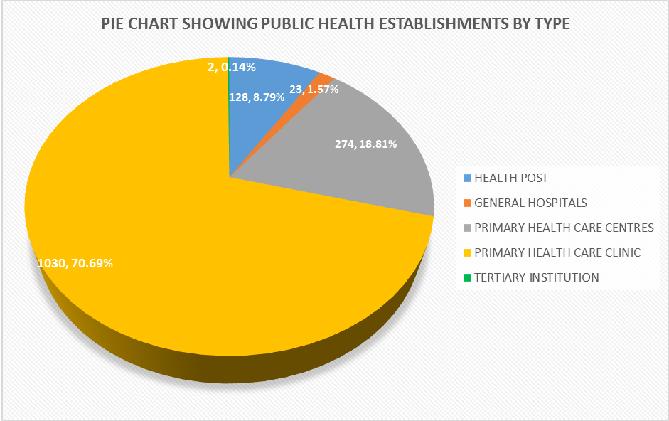
TABLE 3.3
NUMBER OF PRIVATE HEALTH ESTABLISHMENTS IN NIGER STATE BY LGA, 2022
LGA | TYPE OF ESTABLISHMENT |  |  |  |  |  |  |  | Total
LGA | BHC | Clinic | Secondary  Hospital | Health Post | Hospital | Maternity | MCH | PHC | Total
AGAIE |  |  | 2 |  |  |  |  | 8 | 10
AGWARA |  |  | 0 |  |  |  |  | 2 | 2
BIDA |  |  | 21 |  |  |  |  | 30 | 51
BORGU |  |  | 12 |  |  |  |  | 12 | 24
BOSSO |  |  | 8 |  |  |  |  | 53 | 61
CHANCHAGA |  |  | 48 |  |  |  |  | 42 | 90
EDATI |  |  | 1 |  |  |  |  | 6 | 7
GBAKO |  |  | 1 |  |  |  |  | 4 | 5
GURARA |  |  | 2 |  |  |  |  | 23 | 25
KATCHA |  |  | 0 |  |  |  |  | 15 | 15
KONTAGORA |  |  | 5 |  |  |  |  | 13 | 18
LAPAI |  |  | 3 |  |  |  |  | 44 | 47
LAVUN |  |  | 1 |  |  |  |  | 12 | 13
MAGAMA |  |  | 1 |  |  |  |  | 9 | 10
MARIGA |  |  | 1 |  |  |  |  | 25 | 26
MASHEGU |  |  | 1 |  |  |  |  | 48 | 49
MOKWA |  |  | 2 |  |  |  |  | 10 | 12
MUNYA |  |  | 1 |  |  |  |  | 24 | 25
PAIKORO |  |  | 2 |  |  |  |  | 56 | 58
RAFI |  |  | 4 |  |  |  |  | 24 | 28
RIJAU |  |  | 0 |  |  |  |  | 4 | 4
SHIRORO |  |  | 2 |  |  |  |  | 70 | 72
SULEJA |  |  | 46 |  |  |  |  | 45 | 91
TAFA |  |  | 12 |  |  |  |  | 35 | 47
WUSHISHI |  |  | 0 |  |  |  |  | 12 | 12
TOTAL |  |  | 176 |  |  |  |  | 626 | 802

TABLE 3.4: SUMMARY OF PRIVATE HEALTH ESTABLISHMENTS IN NIGER, 2022
TYPE OF HEALTH ESTABLISHMENT | FREQUENCY | PERCENT
SECONDARY HOSPITAL | 176 | 21.95
PRIMARY HEALTH CARE CLINIC | 626 | 78.05
Total | 802 | 100

Figure 4: PIE CHART SHOWING PRIVATEHEALTH ESTABLISHMENTS BY TYPE

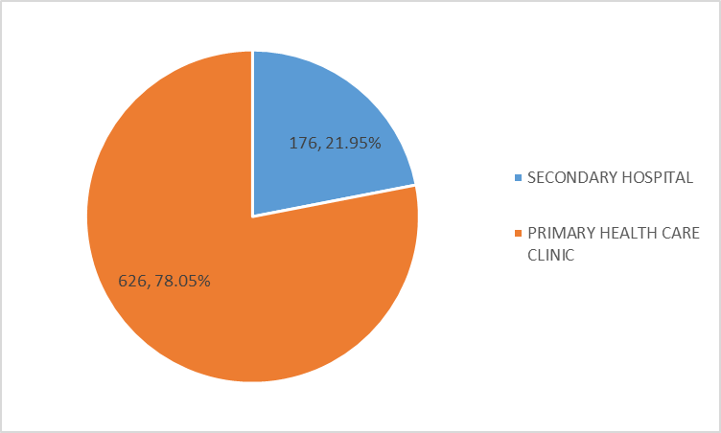

CHAPTER FOUR
Sources of Drinking Water in Wards of Niger State, 2022
This chapter dwelt on the main and alternative sources of drinking water as well as functional/non-functional Boreholes in the 274 Wards of the State.
Table 4.1 indicates that Borehole is the main source of drinking water in 177 (52.06%) wards while only 42 (12.35%) of the Wards has access to Pipe-Borne Water in the State. However, out of the 42 Wards that have access to Pipe-Borne water as their main source of drinking water, 9 (21.43%) are located in Chanchaga LGA, which houses the State Capital.
Table 4.2 provides data on alternative sources of drinking water. From the table, Borehole also serves as the alternative source of drinking in majority of the wards i.e. 172 (50.59%) of the 274 wards in the State.
Tables 4.3.1 – 4.3.25 provide data on functional and non-functional Boreholes in the State. 7,641 functional and non-functional Boreholes were reported that made up of 4,212 (55.12%) as functional and 3,429 (44.88%) were non-functional. Bida LGA has the highest number of functional Boreholes with 1,063 (25.24%) followed by Mokwa LGA with 387(9.19%) functional boreholes while Chanchaga and Edati LGAs have the least number of 31 (0.74%) each of the functional Boreholes. Bida LGA has the highest number of 425 (12.39%) non-functional Boreholes followed by Mokwa LGA with 412(12.02%) non-functional boreholes.

TABLE 4.1 MAIN SOURCE OF DRINKING WATER BY LGAs, 2022
S/NO | LGA | PIPE BORNE WATER | BOREHOLES | WELL | TANKER/ TRUCK | RAIN WATER | RIVER/ STREAM | WATER VENDOR
1 | Agaie | 1 | 7 | 2 | - | - | 1 | -
2 | Agwara | - | 1 | 5 |  | 1 | 4 | -
3 | Bida | 3 | 11 | 1 | - | - | - | -
4 | Borgu | 0 | 10 | 3 |  |  | 0 | -
5 | Bosso | 4 | 6 | - | - | - | - | -
6 | Chanchaga | 9 | 2 | - | - | - | - | -
7 | Edati | 1 | 9 | 1 |  | 4 | 4 | -
8 | Gbako | 4 | 10 | - | - | - | - | -
9 | Gurara | 1 | 10 |  |  | 2 | 2 | -
10 | Kontagora | - | 8 | 7 | 4 | - | 1 | -
11 | Katcha | 1 | 5 | 2 |  | 1 | 2 | -
12 | Lapai | 1 | 9 | 1 | 1 | - | 2 | -
13 | Lavun | - | 2 | 5 | - | 2 | 2 | -
14 | Magama | 1 | 9 | 3 |  |  | 5 | -
15 | Mariga | - | 1 | 10 | - | - | - | -
16 | Mashegu | - | 7 | 10 | - | - | - | -
17 | Mokwa | 2 | 5 | 2 |  |  | 4 | -
18 | Munya | 1 | 2 | 3 | - | - | -6 | -
19 | Paikoro | 3 | 8 | - | - | - | 1 | -
20 | Rafi | 1 | 11 | - | - | - | 3 | -
21 | Rijau | - | 10 | 2 | - | - | - | -
22 | Shiroro | 2 | 13 | 3 |  | 1 | 2 | -
23 | Suleja | 5 | 5 | - | - | - | - | -
24 | Tafa | 2 | 8 | 1 | - | - | - | -
25 | Wushishi | - | 8 | 2 | - | - | 3 | -
TOTAL |  | 42 | 177 | 63 | 5 | 11 | 42 | 0

TABLE 4.2 ALTERNATIVE SOURCES OF DRINKING WATER BY LGAs, 2022
Name of LGA | Borehole | Well | Tanker/Truck | Rain Water | River/Stream | Water Vendor | Package  Water
AGAIE | 3 | 9 | 0 | 11 | 10 | 5 | 9
AGWARA | 8 | 3 | 1 | 7 | 2 | 8 | 1
BIDA | 0 | 7 | 0 | 13 | 6 | 3 | 8
BORGU | 0 | 3 | 2 | 10 | 7 | 1 | 7
BOSSO | 6 | 10 | 5 | 1 | 4 | 7 | 10
CHANCHAGA | 10 | 4 | 3 | 5 | 1 | 7 | 11
EDATI | 10 | 10 | 3 | 9 | 6 | 0 | 6
GBAKO | 2 | 10 | 0 | 10 | 10 | 6 | 4
GURARA | 0 | 4 | 0 | 0 | 6 | 0 | 0
KATCHA | 7 | 9 | 2 | 8 | 8 | 5 | 4
KONTAGORA | 4 | 12 | 7 | 12 | 6 | 10 | 13
LAPAI | 10 | 10 | 2 | 10 | 10 | 3 | 10
LAVUN | 12 | 8 | 0 | 5 | 6 | 0 | 3
MAGAMA | 0 | 3 | 2 | 10 | 6 | 11 | 9
MARIGA | 12 | 11 | 4 | 12 | 10 | 2 | 11
MASHEGU | 5 | 0 | 0 | 10 | 5 | 1 | 0
MOKWA | 9 | 6 | 0 | 6 | 7 | 6 | 3
MUNYA | 3 | 4 | 0 | 11 | 11 | 0 | 0
PAIKORO | 11 | 3 | 0 | 9 | 9 | 0 | 0
RAFI | 11 | 11 | 0 | 11 | 3 | 0 | 4
RIJAU | 10 | 10 | 0 | 10 | 4 | 8 | 2
SHIRORO | 13 | 6 | 2 | 15 | 13 | 2 | 5
SULEJA | 10 | 10 | 0 | 10 | 2 | 8 | 8
TAFA | 7 | 7 | 1 | 9 | 2 | 3 | 8
WUSHISHI | 9 | 4 | 1 | 6 | 3 | 4 | 9
Total | 172 | 174 | 35 | 220 | 157 | 100 | 145

TABLE 4.3: NUMBER OF FUNCTIONAL AND NON-FUNCTIONAL
BOREHOLES IN NIGER STATE BY LGA, 2022

LGA | Functional Boreholes | Non-Functional Boreholes | TOTAL | Percentage of TOTAL
AGAIE | 178 | 153 | 331 | 4.33
AGWARA | 168 | 121 | 289 | 3.78
BIDA | 1063 | 425 | 1488 | 19.47
BORGU | 131 | 118 | 249 | 3.26
BOSSO | 103 | 100 | 203 | 2.66
CHANCHAGA | 31 | 95 | 126 | 1.65
EDATI | 31 | 86 | 117 | 1.53
GBAKO | 89 | 18 | 107 | 1.40
GURARA | 136 | 117 | 255 | 3.34
KATCHA | 161 | 166 | 327 | 4.28
KONTAGORA | 221 | 136 | 357 | 4.67
LAPAI | 93 | 98 | 191 | 2.50
LAVUN | 174 | 200 | 374 | 4.89
MAGAMA | 108 | 142 | 250 | 3.27
MARIGA | 108 | 155 | 273 | 3.44
MASHEGU | 55 | 95 | 150 | 1.96
MOKWA | 387 | 412 | 799 | 10.46
MUNYA | 210 | 29 | 239 | 3.13
PAIKORO | 160 | 152 | 312 | 4.08
RAFI | 81 | 91 | 172 | 2.25
RIJAU | 90 | 102 | 192 | 2.51
SHIRORO | 112 | 81 | 193 | 2.53
SULEJA | 115 | 175 | 290 | 3.80
TAFA | 45 | 28 | 73 | 0.96
WUSHISHI | 160 | 134 | 294 | 3.85
TOTAL | 4,212 | 3,429 | 7,641 | 100

DISTRIBUTION OF BOREHOLES BY WARD AND LGA, 2022

TABLE 4.3.1 AGAIE LOCAL GOVERNMENT AREA
S\N | NAME OF WARD | Functional Boreholes | Non Functional Boreholes | Total Number of Boreholes
1 | Baro | 29 | 15 | 44
2 | Boku | 25 | 19 | 44
3 | Ekobadegi | 21 | 6 | 27
4 | Etsugaie | 15 | 49 | 64
5 | Ekossa | 25 | 5 | 30
6 | Ekowuna | 16 | 4 | 20
7 | Magaji | - | - | -
8 | Kutiriko | 8 | 10 | 18
9 | Ewugi | 9 | 8 | 17
10 | Tagagi | 20 | 30 | 50
11 | Eko-Wugi | 10 | 7 | 17
 | Total | 178 | 153 | 331

TABLE 4. 3.2 AGWARA LOCAL GOVERNMENT AREA
S/N | Name of Ward | Functional Boreholes | Non Functional Boreholes | Total Number of Boreholes
1 | Adahe | 15 | 15 | 30
2 | Agwara | 10 | 10 | 20
3 | Bunsuru | 16 | 8 | 24
4 | Gallah | 20 | 15 | 35
5 | Kashini | 20 | 25 | 45
6 | Kokoli | 9 | 6 | 15
7 | Mago | 15 | 10 | 25
8 | Papiri | 30 | 20 | 50
9 | Rofia | 17 | 6 | 23
10 | Suteko | 16 | 6 | 22
 | Total | 168 | 121 | 289

DISTRIBUTION OF BOREHOLESS BY WARD AND LGA, 2022

TABLE 4.3.3 BIDA LOCAL GOVERNMENT AREA
S\N | NAME OF WARD | Functional Boreholes | Non Functional Boreholes | Total Number of Boreholes
1 | Bariki | 25 | 10 | 35
2 | Ceniyan | 22 | 18 | 40
3 | Dokodza | 720 | 130 | 850
4 | Kyari | 20 | 0 | 20
5 | Landzu | 25 | 15 | 40
6 | Masaba1 | 15 | 5 | 20
7 | Masaba11 | 8 | 5 | 13
8 | Masaga1 | 9 | 104 | 113
9 | Masaga11 | 63 | 38 | 101
10 | MaiyakiNdajiya | 8 | 6 | 14
11 | Nasarafu | 80 | 40 | 120
12 | Umara Ma'ajigi 1 | 48 | 42 | 90
13 | Umara Ma'ajigi 11 | 0 | 2 | 2
14 | Wadata | 20 | 10 | 30
 | Total | 1,063 | 425 | 1,488

TABLE 4.3.4 BORGU LOCAL GOVERNMENT AREA
S/N | Name of Ward | Functional Boreholes | Non Functional Boreholes | Total Number of Boreholes
1 | Rafi | 15 | 17 | 32
2 | Karabonde | 5 | 14 | 19
3 | Konkoso | 16 | 4 | 20
4 | Bussa | 31 | 17 | 48
5 | Malale | 4 | 2 | 6
6 | Bugga | - | 12 | 12
7 | Babanna | 20 | 10 | 30
8 | Pissa/kabe | 8 | 5 | 13
9 | Shagunu | 9 | 12 | 21
10 | Wawa | 23 | 25 | 48
 | Total | 131 | 118 | 249

DISTRIBUTION OF BOREHOLESS BY WARD AND LGA, 2022

TABLE 4.3.5 BOSSO LOCAL GOVERNMENT AREA
S\N | NAME OF WARD | Functional Boreholes | Non Functional Boreholes | Total Number of Boreholes
1 | Beji | 6 | 10 | 16
2 | Bosso Central 1 | 8 | 10 | 18
3 | Bosso Central 11 | 9 | 13 | 22
4 | Chanchaga | 12 | 10 | 22
5 | Garatu | 9 | 15 | 24
6 | Kampala | 20 | 10 | 30
7 | Kodo | 6 | 7 | 13
8 | Maikunkele | 11 | 8 | 19
9 | Maitumbi | 17 | 3 | 20
10 | Shatta | 5 | 14 | 19
 | Total | 103 | 100 | 203

TABLE 4.3.6 CHANCHAGA LOCAL GOVERNMENT AREA
S\N | NAME OF WARD | Functional Boreholes | Non Functional Boreholes | Total Number of Boreholes
1 | Nassarawa 'A' | 2 | 1 | 3
2 | Nassarawa 'B' | 1 | 3 | 4
3 | Nassarawa 'C' | 3 | 4 | 7
4 | Tundun Wada South | 1 | 10 | 11
5 | Makera | 1 | 8 | 9
6 | Sabongari | 6 | 12 | 18
7 | Minna Central | 4 | 10 | 14
8 | Minna South | 3 | 19 | 22
9 | Tundun Wada North | 5 | 13 | 18
10 | Limawa 'A' | 3 | 3 | 6
11 | Limawa 'B' | 2 | 12 | 14
 | Total | 31 | 95 | 126

DISTRIBUTION OF BOREHOLESS BY WARD AND LGA, 2022

TABLE 4.3.7 EDATI LOCAL GOVERNMENT AREA
S/N | Name of Ward | Functional Boreholes | Non Functional Boreholes | Total Number of Boreholes
1 | Rokota | 2 | 11 | 13
2 | Gazhe i | 5 | 8 | 13
3 | Gazhe ii | 2 | 15 | 17
4 | Gonaagi | 4 | 8 | 12
5 | Enagi | 4 | 15 | 19
6 | Sakpe | 2 | 7 | 19
7 | Guzzan | 2 | 5 | 7
8 | EtsuTashe | 3 | 10 | 13
9 | Fazhi | 2 | 5 | 7
10 | Gbagban | 5 | 2 | 7
 | Total | 31 | 86 | 117

TABLE 4.3.8 GBAKO LOCAL GOVERNMENT AREA
S\N | NAME OF WARD | Functional Boreholes | Non Functional Boreholes | Total Number of Boreholes
1 | Batako | 16 | 0 | 16
2 | Edozhigi | 15 | 0 | 15
3 | Etsu-Audu | 20 | 0 | 20
4 | Gbadafu | 4 | 0 | 4
5 | Edokota | 3 | 0 | 3
6 | Gogata | 7 | 7 | 14
7 | Lemu | 11 | 0 | 11
8 | Nuwankota | 2 | 0 | 2
9 | Sommajiko | 5 | 5 | 10
10 | Batagi | 6 | 6 | 12
 | Total | 89 | 18 | 107

DISTRIBUTION OF BOREHOLESS BY WARD AND LGA, 2022

TABLE 4.3.9 GURARA LOCAL GOVERNMENT AREA
S/N | Name of Ward | Functional Boreholes | Non Functional Boreholes | Total Number of Boreholes
1 | Bonu | 6 | 2 | 8
2 | Diko | 20 | 15 | 35
3 | Gawu | 17 | 0 | 17
4 | Izon | 16 | 4 | 20
5 | Kabo | 8 | 12 | 20
6 | Kwaka | 10 | 15 | 25
7 | Lambata | 30 | 20 | 50
8 | Lefu | 11 | 15 | 26
9 | Shako | 5 | 20 | 25
10 | Tufa | 13 | 14 | 27
 | Total | 136 | 117 | 253

TABLE 4.3.10 KATCHA LOCAL GOVERNMENT AREA
S/N | Name of Ward | Functional Boreholes | Non Functional Boreholes | Total Number of Boreholes
1 | Bisanti | 30 | 8 | 38
2 | Baddegi | 70 | 40 | 110
3 | Essa | 15 | 10 | 25
4 | Kateeregi | 10 | 12 | 22
5 | Sidi-Saba | 8 | 12 | 20
6 | Dzwafu | 10 | 15 | 25
7 | Bakeko | 6 | 4 | 10
8 | Gbakogi | 5 | 25 | 30
9 | Edotsu | 5 | 36 | 41
10 | Katcha | 2 | 4 | 6
 | Total | 161 | 166 | 327

DISTRIBUTION OF BOREHOLESS BY WARD AND LGA, 2022

TABLE 4.3.11 KONTAGORA LOCAL GOVERNMENT AREA
S\N | NAME OF WARD | Functional Boreholes | Non Functional Boreholes | Total Number of Boreholes
1 | Masuga | 14 | 10 | 24
2 | Arewa | 18 | 7 | 25
3 | Madara | 11 | 9 - | 20
4 | Nagwamatse | 20 | 9 | 29
5 | Central | 23 | 12 | 35
6 | Rafin Gora | 2 | 8 | 10
7 | Kudu | 28 | 12 | 40
8 | TuganKawo | 6 | 9 | 15
9 | Tugan Wawa | 10 | 10 | 20
10 | Usalle | 5 | 15 | 20
11 | Magajiya | 19 | 7 | 26
12 | Yamma | 35 | 35 | 70
13 | Gabas | 30 | 15 | 45
 | Total | 221 | 136 | 357

TABLE 4.3.12 LAPAI LOCAL GOVERNMENT AREA
S\N | NAME OF WARD | Functional Boreholes | Non Functional Boreholes | Total Number of Boreholes
1 | GupaAbugi | 1 | 4 | 5
2 | Muye-Egba | 18 | 2 | 20
3 | Kudu/Kabe | 16 | 4 | 20
4 | Arewa/Yamma | 2 | 5 | 7
5 | Evuti/Kpada | 10 | 55 | 65
6 | BirinMaza/Tashibo | 1 | 1 | 2
7 | Takuti/Ishaku | 6 | 2 | 8
8 | Ebbo/Gbacinko | 14 | 2 | 16
9 | Duma/Zago | 10 | 2 | 12
10 | GuluAnguwa/G.Vatsa | 15 | 11 | 26
 | Total | 93 | 98 | 191

DISTRIBUTION OF BOREHOLESS BY WARD AND LGA, 2022

TABLE 4.3.13 LAVUN LOCAL GOVERNMENT AREA
S/N | Name of Ward | Functional Boreholes | Non Functional Boreholes | Total Number of Boreholes
1 | Busu | 0 | 20 | 20
2 | Batati | 0 | 0 | 0
3 | Dassun | 4 | 7 | 11
4 | Doko | 21 | 9 | 30
5 | Dabban | 5 | 7 | 12
6 | Egbako | 5 | 20 | 25
7 | Gaba | 0 | 0 | 0
8 | Jima | 100 | 50 | 150
9 | Kutigi | 35 | 74 | 109
10 | Kusotachi | 0 | 0 | 0
11 | Lagun | 3 | 12 | 15
12 | Mambe | 1 | 1 | 2
 | Total | 174 | 200 | 374

TABLE 4.3.14 MAGAMA LOCAL GOVERNMENT AREA
S\N | NAME OF WARD | Functional Boreholes | Non Functional Boreholes | Total Number of Boreholes
1 | Nasko | 9 | 12 | 21
2 | Ibelu Central | 9 | 14 | 23
3 | Ibelu North | 8 | 13 | 21
4 | Ibelu West | 6 | 5 | 11
5 | Auna Central | 8 | 14 | 18
6 | Auna East | 6 | 14 | 20
7 | Salka Central | 12 | 15 | 27
8 | Kawo | 6 | 7 | 15
9 | Nassarawa | 9 | 10 | 19
10 | TungaJika | 6 | 5 | 11
11 | Yangalu | 8 | 13 | 21
12 | Anaba | 4 | 4 | 8
13 | MagamanDaji | 8 | 7 | 15
14 | Kura | 9 | 9 | 18
 | Total | 108 | 142 | 250

DISTRIBUTION OF BOREHOLESS BY WARD AND LGA, 2022

TABLE 4.3.15 MARIGA LOCAL GOVERNMENT AREA
S\N | NAME OF WARD | Functional Boreholes | Non Functional Boreholes | Total Number of Boreholes
1 | Inkwai | 15 | 20 | 45
2 | Beri | 10 | 10 | 20
3 | GaimaWamba | 8 | 11 | 19
4 | Maburya | 5 | 12 | 17
5 | Kumbashi | 7 | 10 | 17
6 | Bangi | 15 | 25 | 40
7 | Bobi | 11 | 14 | 25
8 | G/Boka | 10 | 15 | 25
9 | Kakihun | 6 | 9 | 15
10 | Kotonkoro | 12 | 18 | 30
11 | Igwama | 9 | 11 | 20
 | Total | 108 | 155 | 273

TABLE 4.3.16 MASHEGU LOCAL GOVERNMENT AREA
S\N | NAME OF WARD | Functional Boreholes | Non Functional Boreholes | Total Number of Boreholes
1 | Sahon Rami | 7 | 11 | 18
2 | Mashegu | 4 | 8 | 12
3 | Kasanga | 5 | 9 | 14
4 | Mazakuka | 4 | 8 | 12
5 | Kaboji | 7 | 13 | 20
6 | Ibbi | 4 | 9 | 13
7 | Dafagi/Makera | - | - | -
8 | Kpatachin | - | - | -
9 | Babban Rami | 6 | 12 | 18
10 | Kulho | 6 | 7 | 13
11 | Kwatachi | 5 | 8 | 13
12 | Manigi | 7 | 10 | 17
 | Total | 55 | 95 | 150

DISTRIBUTION OF BOREHOLESS BY WARD AND LGA, 2022

TABLE 4.3.17 MOKWA LOCAL GOVERNMENT AREA
S/N | Name of Ward | Functional Boreholes | Non Functional Boreholes | Total Number of Boreholes
1 | Bokani | 7 | 13 | 20
2 | Muwo/Gbajibo | 10 | 30 | 40
3 | Gbara | 7 | 10 | 17
4 | Ja'agi | 7 | 1 | 8
5 | Jebba | 9 | 11 | 20
6 | Kpaki | 16 | 14 | 30
7 | Kudu | 5 | 5 | 10
8 | Labozhi | 20 | 10 | 30
9 | Mokwa Central | 300 | 300 | 600
10 | Muregi | 3 | 7 | 10
11 | Rabba/Ndayako | 3 | 11 | 14
 | Total | 387 | 412 | 799

TABLE 4.3.18 MUNYA LOCAL GOVERNMENT AREA
S\N | NAME OF WARD | Functional Boreholes | Non Functional Boreholes | Total Number of Boreholes
1 | Fuka | 24 | 8 | 32
2 | Danguna | 16 | 2 | 18
3 | Kabula | 7 | 5 | 12
4 | Kunchi | 14 | 8 | 22
5 | Gini | 13 | 12 | 25
6 | Daza | 6 | 18 | 24
7 | Beni | 12 | - | 12
8 | Wazai | 5 | 11 | 16
9 | Guni | 25 | - | 25
10 | Sarkin-Pawa | 15 | 10 | 25
11 | Dan-Daudu | 73 | -45 | 28
 | Total | 210 | 29 | 239

DISTRIBUTION OF BOREHOLESS BY WARD AND LGA, 2022

TABLE 4.3.19 PAIKORO LOCAL GOVERNMENT AREA
S\N | NAME OF WARD | Functional Boreholes | Non Functional Boreholes | Total Number of Boreholes
1 | Aduna | 1 | 7 | 8
2 | Chimbi | 10 | 10 | 20
3 | Gwam | 9 | 11 | 20
4 | Ishan | 10 | 11 | 21
5 | Jere | 8 | 11 | 19
6 | Kafinkoro | 15 | 14 | 29
7 | Kwangana | 20 | 10 | 30
8 | Kwakuti | 15 | 15 | 30
9 | Nikuchi/T/Mallam | 20 | 20 | 40
10 | Paiko Central | 21 | 19 | 40
11 | Tutungo | 31 | 24 | 55
 | Total | 160 | 152 | 312

TABLE 4.3.20 RAFI LOCAL GOVERNMENT AREA
S\N | NAME OF WARD | Functional Boreholes | Non Functional Boreholes | Total Number of Boreholes
1 | Kagara Gari | 1 | 0 | 1
2 | Kakuri | - | - | -
3 | Kongoma Central | 12 | 9 | 21
4 | Kongoma West | 6 | 4 | 10
5 | Kusherki North | 2 | 0 | 2
6 | Kusherki South | 2 | 8 | 10
7 | Kundu | 10 | 25 | 35
8 | Sabongari | 15 | 5 | 20
9 | TeginaGari | 10 | 5 | 15
10 | Tegina West | 8 | 4 | 12
11 | Yakila | 2 | 20 | 22
12 | Madaka | 13 | 11 | 24
 | Total | 81 | 91 | 172

DISTRIBUTION OF BOREHOLESS BY WARD AND LGA, 2022

TABLE 4.3.21 RIJAU LOCAL GOVERNMENT AREA
S\N | NAME OF WARD | Functional Boreholes | Non Functional Boreholes | Total Number of Boreholes
1 | Danrangi | - | - | -
2 | Dugge | 1 | - | 1
3 | Dukku | 16 | 7 | 23
4 | Genu | 2 | 12 | 14
5 | Jam'are | 1 | 1 | 2
6 | Rijau | 23 | 39 | 62
7 | Shambo | 11 | 5 | 16
8 | TunganBunu | 3 | 11 | 14
9 | TunganMagajiya | 9 | 2 | 11
10 | SabonGarinUshe | 9 | 4 | 13
11 | Warari | 15 | 21 | 36
 | Total | 90 | 102 | 192

TABLE 4.3.22 SHIRORO LOCAL GOVERNMENT AREA
S/N | Name of Ward | Functional Boreholes | Non Functional Boreholes | Total Number of Boreholes
1 | Galkogo | 5 | 15 | 20
2 | Erena | 5 | 5 | 10
3 | Kwaki/chukuba | 1 | 0 | 1
4 | Gurmana | 2 | 1 | 3
5 | Allawa | 7 | 3 | 10
6 | Bangajiya | 11 | 4 | 15
7 | Gussoro | 0 | 0 | 0
8 | Ubandoma | 5 | 12 | 17
9 | Egwa/Gwada | 36 | 6 | 42
10 | Pina | 7 | 12 | 19
11 | Kato | 15 | 1 | 16
12 | She | 9 | 12 | 21
13 | Bassa/kukoki | 8 | 4 | 12
14 | Kurebe/kushaka | 1 | 2 | 3
15 | Manta | 0 | 4 | 4
 | Total | 112 | 81 | 193

DISTRIBUTION OF BOREHOLESS BY WARD AND LGA, 2022

TABLE 4.3.23 SULEJA LOCAL GOVERNMENT AREA
S/N | Name of Ward | Functional Boreholes | Non Functional Boreholes | Total Number of Boreholes
1 | Bagama 'A' | 10 | 30 | 40
2 | Bagama 'B' | 23 | 31 | 54
3 | Magajiya | 7 | 8 | 15
4 | Iku south i | 20 | 40 | 60
5 | Iku south ii | 8 | 12 | 20
6 | Hashimi 'A' | 15 | 28 | 43
7 | Hashimi 'B' | 7 | 8 | 15
8 | Maje | 7 | 5 | 12
9 | Kurmisarki | 8 | 7 | 15
10 | Wambai | 10 | 6 | 16
 | Total | 115 | 175 | 290

TABLE 4.3.24 TAFA LOCAL GOVERNMENT AREA
S\N | NAME OF WARD | Functional Boreholes | Non Functional Boreholes | Total Number of Boreholes
1 | DogonKurmi | 8 | 2 | 10
2 | New Bwari | 5 | 5 | 10
3 | Zuma West | 0 | 0 | 0
4 | Zuma East | 0 | 0 | 0
5 | Wuse West | 8 | 4 | 12
6 | Wuse East | 4 | 4 | 8
7 | Iku | 11 | 9 | 20
8 | IjaKoro | 4 | 1 | 5
9 | IjaGbagyi | 5 | 3 | 8
10 | Garam | 10 | 4 | 14
 | Total | 45 | 28 | 73

DISTRIBUTION OF BOREHOLESS BY WARD AND LGA, 2022

TABLE 4.3.25 WUSHISHI LOCAL GOVERNMENT AREA
S\N | NAME OF WARD | Functional Boreholes | Non Functional Boreholes | Total Number of Boreholes
1 | SabonGari | 16 | 8 | 24
2 | Kwata | 14 | 10 | 24
3 | Barwa | 7 | 9 | 16
4 | Lokogoma | 18 | 10 | 28
5 | Maito | 11 | 13 | 24
6 | Kodo | 21 | 14 | 35
7 | Gwarjiko | 8 | 14 | 22
8 | Zungeru | 25 | 25 | 50
9 | T/Yamigi | 17 | 16 | 33
10 | Akare | 15 | 7 | 22
11 | Kanwuri | 8 | 8 | 16
 | Total | 160 | 134 | 294

CHAPTER FIVE
Sources of Agricultural Inputs in Wards of Niger State, 2022
This section dealt with the sources of agricultural inputs such as fertilizer, seedlings, insecticides, pesticides and herbicides.
FERTILIZER
Table 5.1 shows that 97 wards obtain fertilizer from Government sources, 163 from Open market and 114 from both sources (Government/Open market).

TABLE 5.1 NUMBER OF WARDS WITH ACCESS TO FERTILIZER BY
SOURCE AND LGA 2022
LGA |  | SOURCE
 |  | GOVERNMENT |  |  | OPEN MARKET | GOVT/OPEN MARKET | OTHERS
AGAIE |  | 9 |  |  | 11
AGWARA |  | 3 |  |  | 10 | 6
BIDA |  | 3 |  |  | 10 | 8
BORGU |  | 7 |  |  | 10
BOSSO |  | 3 |  |  | 10 | 5
CHANCHAGA |  | 5 |  |  | 11 | 6
EDATI |  | 9 |  |  | 10
GBAKO |  |  |  |  | 10 | 9
GURARA |  | 8 |  |  | 10 | 2
KATCHA |  | 9 |  |  | 10
KONTAGORA |  | 3 |  |  | 13 | 7
LAPAI |  | 3 |  |  | 10 | 2
LAVUN |  | 3 |  |  | 9 | 4
MAGAMA |  | 1 |  |  | 11 | 8
MARIGA |  | 2 |  |  | 12 | 8
MASHEGU |  | 8 |  |  | 10 | 1
MOKWA |  | 3 |  |  | 10 | 8
MUNYA |  |  |  |  | 11 | 9
PAIKORO |  | 1 |  |  | 9 | 8
RAFI |  | 3 |  |  | 11 | 6
RIJAU |  | 2 |  |  | 10 | 9
SHIRORO |  | 2 |  |  | 15
SULEJA |  | 2 |  |  | 8 | 8
TAFA |  | 1 |  |  | 10
WUSHISHI |  | 7 |  |  | 3
TOTAL |  | 97 |  |  | 163 | 114
SEEDLINGS
Table 5.2 revealed that 38 wards obtain seedlings from the Government, 251 from Open Market and 50 from Government/Open market.

TABLE 5.2 NUMBER OF WARDS WITH ACCESS TO SEEDLINGS BY SOURCE AND LGA 2022
LGA | SOURCE
LGA | GOVERNMENT | OPEN MARKET | GOVT/OPEN MARKET | OTHERS
AGAIE | 9 | 11
AGWARA | 1 | 10 | 2
BIDA | 3 | 7 | 1
BORGU | 1 | 8
BOSSO | - | 10 | 2
CHANCHAGA | 3 | 11 | 4
EDATI | - | 10
GBAKO |  | 10 | 3
GURARA | - | 10 | 1
KATCHA | 2 | 8
KONTAGORA | 1 | 13 | 4
LAPAI | 1 | 10 | 1
LAVUN | 2 | 10 | 3
MAGAMA | - | 11 | -
MARIGA | 3 | 12 | -
MASHEGU | 2 | 8 | 2
MOKWA | 3 | 8 | 4
MUNYA |  | 11 | 2
PAIKORO | - | 11 | 3
RAFI | 2 | 11 | 4
RIJAU | - | 9 | 6
SHIRORO | 1 | 15
SULEJA | - | 10 | 7
TAFA | - | 10 | 1
WUSHISHI | 4 | 7
TOTAL | 38 | 251 | 50

INSECTICIDES
Table 5.3 indicates that 16 wards obtain insecticide from the Government, 265 from Open Market and 25 from Government/Open market.
TABLE 5.3 NUMBER OF WARDS WITH ACCESS TO INSECTICIDES BY SOURCE AND LGA 2022
LGA | SOURCE
LGA | GOVERNMENT | OPEN MARKET | GOVT/OPEN MARKET | OTHERS
AGAIE | 5 | 11 | -
AGWARA | - | 10 | 1
BIDA | 2 | 9 | 1
BORGU | - | 10 | -
BOSSO | - | 10 | 1
CHANCHAGA | 2 | 11 | 1
EDATI | - | 10 | -
GBAKO | - | 10 | 2
GURARA | - | 10 | -
KATCHA | 3 | 10 | -
KONTAGORA | - | 13 | 2
LAPAI | - | 10 | 1
LAVUN | 2 | 10 | 1
MAGAMA | - | 11 | -
MARIGA | - | 12 | 1
MASHEGU | - | 10 | 2
MOKWA | - | 10 | -
MUNYA | 1 | 11 | 1
PAIKORO | - | 10 | 2
RAFI | - | 11 | 3
RIJAU | - | 10 | -
SHIRORO | 1 | 15 | 1
SULEJA | - | 10 | 4
TAFA | - | 10 | 1
WUSHISHI | - | 11 | -
TOTAL | 16 | 265 | 25

PESTICIDES
Table 5.4 shows that 13 wards access pesticide through Government, 253 through Open Market and 27 from both sources (Government/Open Market).
TABLE 5.4 NUMBER OF WARDS WITH ACCESS TO PESTICIDES BY SOURCE AND LGA 2022
LGA |  | SOURCE
 |  | GOVERNMENT |  |  | OPEN MARKET | GOVT/OPEN MARKET | OTHERS
AGAIE |  | 4 |  |  | 11
AGWARA |  | - |  |  | 10 | -
BIDA |  | 2 |  |  | 10 | 2
BORGU |  | - |  |  | 10 | -
BOSSO |  | - |  |  | 10 | 1
CHANCHAGA |  | 1 |  |  | 11 | 2
EDATI |  | - |  |  | 10
GBAKO |  |  |  |  | 10 | 2
GURARA |  | - |  |  | 10 | -
KATCHA |  | 2 |  |  | 10
KONTAGORA |  | 1 |  |  | 13 | 2
LAPAI |  | - |  |  | 10 | -
LAVUN |  | 3 |  |  | 9 | -
MAGAMA |  | - |  |  | 11 | -
MARIGA |  | - |  |  | 12 | 1
MASHEGU |  | - |  |  | 10 | 6
MOKWA |  | - |  |  | 10 | -
MUNYA |  | - |  |  | 11 | -
PAIKORO |  | - |  |  | 9 | 2
RAFI |  | - |  |  | 11 | 3
RIJAU |  | - |  |  | 10 | -
SHIRORO |  | - |  |  | 15 | 1
SULEJA |  | - |  |  | 10 | 4
TAFA |  | - |  |  | 10 | 1
WUSHISHI |  | 1 |  |  | 11
TOTAL |  | 14 |  |  | 264 | 27

HERBICIDES
Table 5.5 indicates that 8 wards access Herbicide from the Government, 263 from Open Market and 21 from Government/Open Market.

TABLE 5.5 NUMBER OF WARDS WITH ACCESS TO HERBICIDES BY SOURCE AND LGA, 2022
LGA | SOURCE
LGA | GOVERNMENT | OPEN MARKET | GOVT/OPEN MARKET | OTHERS
AGAIE | 3 | 11
AGWARA | - | 10 | -
BIDA | 2 | 8 | 1
BORGU | - | 10 | -
BOSSO | - | 10 | 1
CHANCHAGA | 1 | 11 | 1
EDATI | - | 10
GBAKO |  | 10 | 1
GURARA | - | 10 | -
KATCHA | - | 10
KONTAGORA | - | 13 | 2
LAPAI | - | 10 | 1
LAVUN | 2 | 10 | -
MAGAMA | - | 11 | -
MARIGA | - | 12 | 2
MASHEGU | - | 10 | -
MOKWA | - | 10 | -
MUNYA | - | 11 | 1
PAIKORO | - | 9 | 1
RAFI | - | 11 | 4
RIJAU | - | 10 | -
SHIRORO | - | 15 | -
SULEJA | - | 10 | 4
TAFA | - | 10 | 2
WUSHISHI | - | 11
TOTAL | 8 | 263 | 21

CHAPTER SIX

DISTRIBUTION OF MAJOR MARKETS AND SLAUGHTER SLABS

Table 6 shows the number of major Markets and Slaughter Slabs in the 25 LGAs of the State. A total of 406 major markets and 288 Slaughter Slabs recorded in the State. From the result of the Census, Shiroro LGA has the highest number of markets with 30 while Chanchaga, Tafa and Edati LGAs have the lowest number of 6 markets each. Similarly, the highest number Slaughter Slabs (34) was recorded in Rijau LGA while Suleja LGA recorded only one which is the least.

TABLE 6: NUMBER OF MAJOR MARKETS AND SLAUGHTER SLABS BY LGA, 2022

S/N | LGAS | NO. OF MAJOR MARKETS | NO. OF SLAUGHTER SLABS
1 | AGAIE | 14 | 4
2 | AGWARA | 13 | 7
3 | BIDA | 12 | 2
4 | BORGU | 34 | 17
5 | BOSSO | 9 | 7
6 | CHANCHAGA | 6 | 11
7 | EDATI | 11 | 8
8 | GBAKO | 5 | 5
9 | GURARA | 6 | 4
10 | KATCHA | 19 | 7
11 | KONTAGORA | 13 | 7
12 | LAPAI | 5 | 4
13 | LAVUN | 28 | 21
14 | MAGAMA | 20 | 34
15 | MARIGA | 14 | 25
16 | MASHEGU | 20 | 21
17 | MOKWA | 27 | 20
18 | MUNYA | 17 | 8
19 | PAIKORO | 20 | 17
20 | RAFI | 25 | 13
21 | RIJAU | 17 | 11
22 | SHIRORO | 30 | 25
23 | SULEJA | 18 | 1
24 | TAFA | 6 | 3
25 | WUSHISHI | 17 | 7
 | G/TOTAL | 406 | 289
CHAPTER SEVEN
Number of Major Motor Parks in Niger State, 2013
A total of 216 major Motor Parks were captured during the Census. These parks are distributed in the 25 LGAs of the State as presented in the table below.
TABLE 7: Number of Major Motor Park by LGA, 2022
LGA | NUMBER OF MAJOR MOTOR PARK
AGAIE | 14
AGWARA | 3
BIDA | 7
BORGU | 11
BOSSO | 3
CHANCHAGA | 17
EDATI | 7
GBAKO | 2
GURARA | 3
KONTAGORA | 10
KATCHA | 10
LAPAI | 3
LAVUN | 20
MAGAMA | 7
MARIGA | 5
MASHEGU | 6
MOKWA | 24
MUNYA | 2
PAIKORO | 16
RAFI | 7
RIJAU | 10
SHIRORO | 16
SULEJA | 7
TAFA | NR
WUSHISHI | 6
G/TOTAL | 216

NOTE: NR implies Not Reported

CHAPTER EIGHT
Banks in Niger State, 2022
Table 8 shows the number of Banks in the 25 LGAs of Niger State. A total of 110 Banks were reported during the Census period in the State with Chanchaga LGA having the highest number of 23. The spread of the banks across the State is as shown in the table below.
TABLE 8: NUMBER OF BANKS IN NIGER STATE BY LGA, 2022
LGA | NUMBER OF BANKS
AGAIE | 1
AGWARA | 1
BIDA | 11
BORGU | 4
BOSSO | 3
CHANCHAGA | 23
EDATI | 1
GBAKO | 1
GURARA | 1
KATCHA | 3
KONTAGORA | 13
LAPAI | 5
LAVUN | 4
MAGAMA | 1
MARIGA | 1
MASHEGU | 1
MOKWA | 3
MUNYA | 1
PAIKORO | 3
RAFI | 2
RIJAU | 2
SHIRORO | 2
SULEJA | 16
TAFA | 1
WUSHISHI | 4
TOTAL | 108

NOTE: NR implies Not Reported
CHAPTER NINE
Hotels/Guest Houses in Niger State, 2022
A total of 288 Hotels/Guest Houses were captured during Census exercise. The table below gives the detailed distribution of these facilities in the State.
TABLE 9: SELECTED HOTELS/GUEST HOUSES IN NIGER STATE BY LGA, 2022
S/NO | NAME OF LGAs | NUMBER OF HOTELS/GUEST HOUSES
1 | AGAIE | 4
2 | AGWARA | 0
3 | BIDA | 18
4 | BORGU | 20
5 | BOSSO | 17
6 | CHANCHAGA | 42
7 | EDATI | 0
8 | GBAKO | 5
9 | GURARA | 9
10 | KATCHA | 1
11 | KONTAGORA | 17
12 | LAPAI | 4
13 | LAVUN | 12
14 | MAGAMA | 9
15 | MARIGA | 3
16 | MASHEGU | 7
17 | MOKWA | 11
18 | MUNYA | 5
19 | PAIKORO | 9
20 | RAFI | 8
21 | RIJAU | 7
22 | SHIRORO | 19
23 | SULEJA | 36
24 | TAFA | 18
25 | WUSHISHI | 7
 | TOTAL | 288

CHAPTER TEN
Access to Electricity in Niger State, 2022
Table 11 shows the number of Wards per LGA that have access to electricity supply.

TABLE 12: NUMBER OF WARDS WITH ACCESS TO ELECTRICITY BY LGA IN NIGER STATE, 2022
S/N | LGA | No. of Wards with Access to Electricity
1 | AGAIE | 10
2 | AGWARA | 7
3 | BIDA | 14
4 | BORGU | 3
5 | BOSSO | 5
6 | CHANCHAGA | 11
7 | EDATI | 1
8 | GBAKO | 9
9 | GURARA | 7
10 | KATCHA | 8
11 | KONTAGORA | 12
12 | LAPAI | 4
13 | LAVUN | 8
14 | MAGAMA | 8
15 | MARIGA | 5
16 | MASHEGU | 6
17 | MOKWA | 9
18 | MUNYA | 7
19 | PAIKORO | 8
20 | RAFI | 8
21 | RIJAU | 6
22 | SHIRORO | 8
23 | SULEJA | 10
24 | TAFA | 10
25 | WUSHISHI | 8
Total |  | 192

Figure 5: NUMBER OF WARDS WITH ACCESS TO ELECTRICITY BY LGA IN NIGER STATE, 2022
